**Manufacturing Project Owner’s Manual**

**ME 240 – Manufacturing**



**Read this Manual Carefully!!**

**Ask Questions as needed.**

**.**

# Project Overview

The goal of this project is to create an injection molded vehicle that will satisfy your customer and compete in the end of semester race. Your customer will be one or more eighth grade students from the Broughal Middle School who will provide you with a concept that you and your teammates will then make a reality.

Your charge is to create the vehicle your customer wants. You will be given basic information about the resources available to you & constraints that you must work within. You will learn skills related to CAD, CAM, NC machining and injection molding via classroom lecture and some of the lab activities.

It is important that you take what you know, apply some common engineering sense and ask questions as needed to ensure successful project completion. Just as important as completing the project is following instructions, filling out necessary paperwork & meeting deadlines for deliverables.

The general progression of the project will be as follows:

1. Obtain concept from customer
2. Create Solid model of vehicle
3. Generate 3D Printed prototype of vehicle
4. Generate solid model of injection molding tool
5. Create NC machining toolpaths for your mold tool geometry
6. Machine Your Mold
7. Injection Mold your vehicles
8. Prepare your vehicle for Race Day



**Figure 1** –Schematic of Main Project Activities (BMS involvement in **highlighted** activities)

One of the main goals of this project is to illustrate the hurdles that must be overcome and the compromises that must be made to take a product from concept to reality. Things such as your knowledge and skill, materials and manufacturing methods available, machinery & tools available, race rules, and time constraints will all play a role in the evolution of your vehicle design as you progress through the project.

The purpose of this manual is to provide a general outline to help you navigate the project from beginning to end. It is NOT intended to provide you with every detail necessary to successfully complete the project. The manual will give you some things to think about & some specifics on the project tasks and related deliverables. It is up to your team to expand on the basic information to produce the best vehicle possible, in the most efficient & cost effective fashion within the constraints that will be placed upon you.

The resources available to you include the following:

* SolidWorks (for solid modeling)
* Makerbot Replicator II 3-D Printer (located at Broughal)
* NX 10.0 (for toolpath generation)
* HAAS VF-2SS & DT-1 (for machining your mold insert plates)
* Nissei PS-40 Injection molding machine
* H-Frame Mold Tool to accept your insert plates
* Polymer Raw Materials (ABS, PC, etc.)
* Course Instructor
* Undergraduate TAs
* Eli Towne

The project will be documented on the [ME 240 Project website](http://www.lehighme240.com/team_index.html). Some of the deliverables you will be submitting will be posted to this website so it is critical that you follow the instructions provided to ensure timely updating and visual consistency of the website. If you have any questions as to what your electronic deliverables should look like you can refer to the 2015 team pages on the project website for examples.

**PRELIMINARY** – Concept Sketch & Meeting at Broughal; Injection Mold Insert Assembly

**PROJECT WEEK 1** – Solid Model of vehicle; Broughal students visit Cad Lab; Create Display Base & 3D Print; Create STL file of Race Vehicle to be 3D printed by Broughal teammates over Spring Break.

**PROJECT WEEK 2** – Create Mold Geometry (cavities, runners & gates)

**PROJECT WEEK 3** – Create NX Toolpaths, Provide EJ pin location & length information, machine mold insert plates in aluminum,

**PROJECT WEEK 4** – Injection Mold your vehicle

**RACE DAY –** Last Day of Classes (Friday at Noon)

# TASK 1 – Kick-Off Meeting & Vehicle Concept

You will meet your Broughal team mates within the first month of the semester at Broughal Middle School —typically a week or so before PROJECT WEEK1 on the Lab schedule. At this time, your Broughal teammates will communicate their ideas for the project to you and your Lehigh teammates. The purpose of the meeting is to decide on a concept that will be pursued for the project. Information such as photos or sketches or even basic CAD models should be provided to you by your Broughal customers or even developed during the meeting. Upon leaving the meeting you should have a good enough idea of what your customer wants that you will be prepared to begin creation of your solid model during Project Week 1.

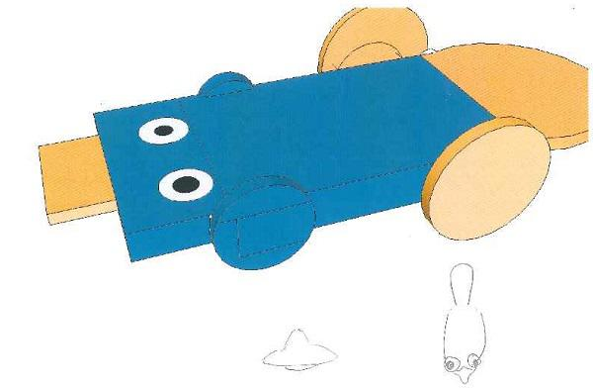 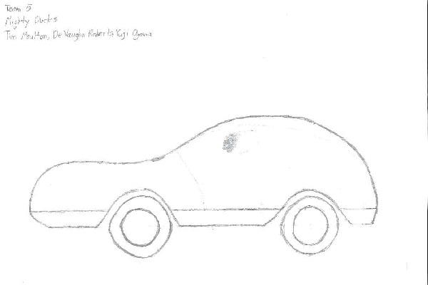

**Figure 2** **–** Sample Concept “Sketches” from prior years

As you discuss concepts, you should keep in mind the constraints placed upon you by the project at hand. These constraints include limitations on your CAD skills as well as those imposed by the chosen manufacturing methods—primarily 3-Axis NC machining and injection molding. The specific equipment and tooling to be used should be considered in your planning and vehicle design. Molds and vehicles from previous years will be available for your reference. Be sure to ask plenty of questions.

**IMPORTANT:** Your customers are middle school students and minor children. You are all legal adults and should act as responsible mentors to the middle school students. Do not exchange personal information, e-mails or phone numbers, or interact directly with the students in person, via e-mail, text or social media outside of the formal channels provided through the ME 240 course.

**Deliverables:**

Completed Team Roster (due at end of Broughal Meeting)

Concept Sketch of suitable quality

**Due Date:** End of Week 1 Project Lab Day

# TASK 2 – Solid Modeling of Vehicle

Based on the concept provided by your customers, your team will create a solid model of your vehicle using Solidworks. Modeling can begin immediately after your concept is provided by your Broughal team members.

During Project Week 1 your Broughal team mates will be in the CAD Lab with you from about 1:30 to 3:00 pm. You should have made SUBSTANTIAL progress on your vehicle solid model by the time you arrive for your Project Week 1 lab time so that you have something to show your Broughal teammates. Involve them in the solid modeling process. Show them how Solidworks is used to create geometry & explain any difficulties you might encounter in modeling certain features OR how certain features may not be able to be machined or injection molded readily.

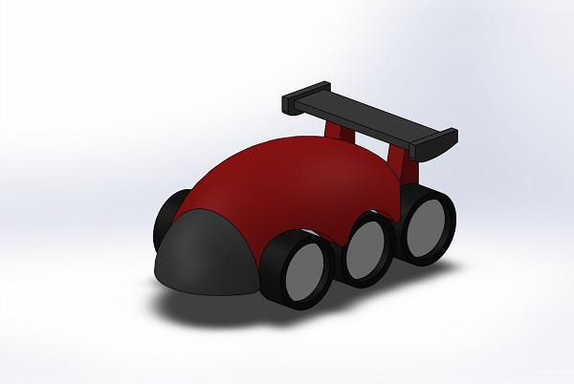

**Figure 3** – Screen Shot of vehicle solid model. Note inclusion of wheels and “paint” scheme.

BEFORE YOU LEAVE your Project Week 1 lab period your group must turn in a vehicle concept sketch (see deliverables info at the end of CONCEPT section above). This should be some kind of sketch, photo or other image that you generated or obtained from your Broughal customers. IT IS NOT to be a screenshot of your SolidWorks Model.

**Additionally, all teams should get their GROUP PHOTO taken during lab week 1.**

Display Base Modeling Activity

To help you demonstrate the capabilities and modeling features of SolidWorks your team will be tasked with creating solid model geometry of a Display Base during Project Week 1. Use the tutorial in Appendix A to create the parts and assembly for the Display Base (see ) with your Broughal teammates present so they get a feel for how solid modeling is done.

Save the assembly as a single STL file and get it printed using the MakerBot 3D printers located in Wilbur. See Appendix A tutorial for all details related to part creation and 3D printing of the Display Base part.

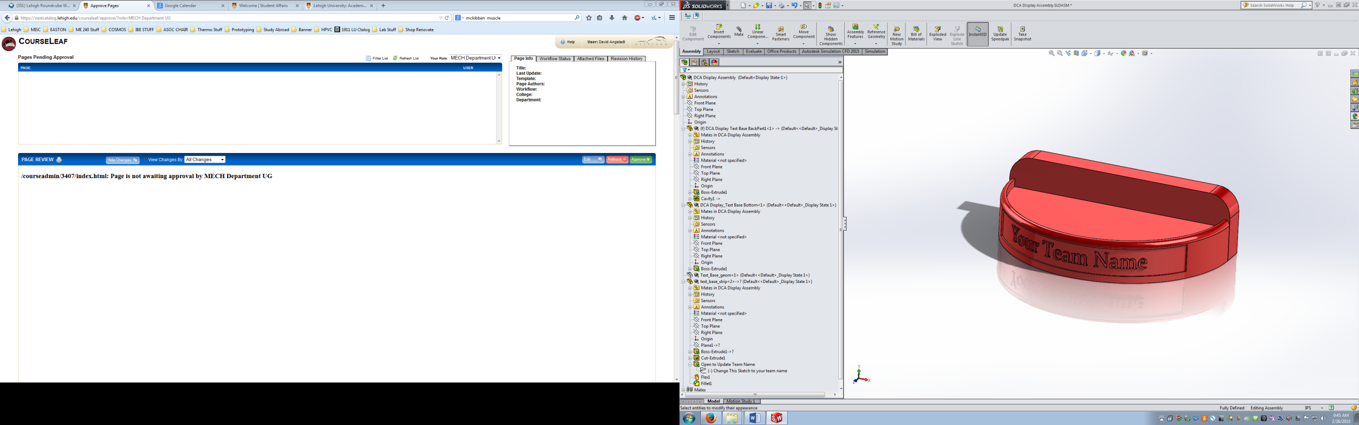 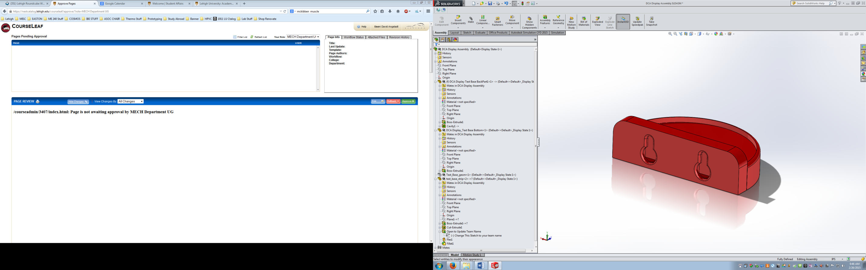

**Figure 4** - Display Base Geometry you will create during Project Week 1 and 3D Print on Makerbot

More on Creating your Vehicle Geometry

The creation of your solid model should be informed by your solid modeling skill, the manufacturing processes and equipment available to you and other limitations placed upon your vehicle design. Realize that you will need to machine a mold for your vehicle, injection mold it using the Nissei PS-40 and race it without interfering with your competitors.

A solid model of the “as-molded” vehicle should be created that is appropriately sized and reflects exactly what you intend your as-molded vehicle to be as far as physical size and geometric features. Note that if you intend to make a hollow or multi-piece vehicle (e.g., 2 halves), your solid model need not necessarily reflect that at this time. In fact, it could be a benefit or a drawback to model your vehicle as such initially—feel free to discuss with course staff if you have any questions.

In addition, separate wheels and axles (ACCURATELY SIZED) should be modeled and added to your car in a SolidWorks assembly to accurately represent the look of your race ready vehicle. You are responsible for purchasing two sets of wheels--one for your “RACE” vehicle & the other for your “SHOW” vehicle. It is recommended that you purchase a hot wheels or matchbox car or two & carefully remove the wheels/axles for use on your vehicle. It is important that you know the tire diameters and the track (tire to tire width) so you can size your vehicle CAD model appropriately.

Note also that your vehicle will need to match up with pre-defined ejector pin locations in the ejector pin plate that is used with the project mold base. A Solidworks assembly of the two pin plates provided is posted to CourseSite. (see ). It is highly recommended that you download this assembly & use the predefined pin locations as a guide when creating your vehicle geometry. Note that you can orient your part horizontally, vertically or at an angle within the mold plate to get it to align with desired ejector pin locations. You need to keep in mind that all of the molded parts of your vehicle need to fit within the 4”x6” x 0.75” think mold plate inserts you will be provided. Also keep in mind that your runners will enter your mold plates from the center section of the mold (e.g., the space between the top and bottom pin plates).



**Figure 5** – Screen shot of Pin Plate Layout Assembly

Thinking ahead to the mold layout portion of the project while designing your vehicle geometry can help make your life easier down the road.

If, for any reason you decide to change your concept, that is permissible, but please submit a new concept sketch. Changing your idea mid-way through the project is not grounds for penalty OR any type of extension. You are still responsible for meeting all deadlines.

Some notes about your SolidWorks solid model:

* **MAKE SURE YOU USE INCHES FOR YOUR UNITS!!**
* Minimize your steps; trying to edit your solid model when the design tree has over 50 features is very difficult.
* Try to stay away from the “cut” or “join” operations as this complicates your feature manager design tree. Using extrude cut or join as a feature is different and acceptable.
* The smallest tool you have available for general vehicle features in your mold is 3/32 inch (0.09375”) diameter; keep this in mind when creating small features.
* You may be able to use smaller tools (e.g., 1/16”) for limited machining of small features if you wish, BUT, you must get permission ahead of time from the instructor.
* Make sure you keep in mind at all times that this part must be made on the injection-molding machine with a simple two plate mold cavity system (be careful of undercuts, sharp edges, and volume).
* Stay on Schedule!! It would be great if you could make an exact 1/50th scale Shelby Cobra; however, it is just as important that you meet all your deadlines.
* Be creative: Creative vehicles will receive a higher score than “Plain Jane” cubes on wheels.
* Pay attention to Detail: Vehicles with unique or detailed features will receive a higher score than those without.
* Multi-piece vehicles and multi-cavity molds are permissible and encouraged. However, you are limited to ONE PAIR of mold plates except for rare instances (see instructor if you think you need two sets)
* Overall, try to keep in mind that you need both to machine a mold and injection mold the car you are creating. These things need to be considered during concept sketches too!
* Designs that are appropriate for injection molding (uniform thin wall thickness) will receive higher grades than designs that are not amenable to injection molding. Poorly designed parts will significantly impact your material costs and molding cycle time.
* You should also design your vehicle so that the as-machined mold geometry is identical to the SolidWorks geometry.
* Apply COLOR to your solid model for the screen shot that you submit—do not submit a boring gray vehicle. Make your solid model aesthetically pleasing. ADD A SET OF WHEELS and AXLES to your solid model for the screen shot. Do this using an ASSEMBLY. DO NOT make the wheels and axles integral to the SolidWorks PART that is your vehicle body.

**Vehicle Geometry Deliverables:**

1. 3D PDF of “race ready” Vehicle CAD model assembly—complete with wheels and color scheme

File Name = 3D-PDF_Vehicle_XX.pdf

1. Screen shot of CAD model File Name = CAD_Vehicle_XX.jpg

Screen shot should be 600 pixels wide by about 350 to 400 pixels high (see Figure 3 above)

**See** **Appendix B** **for more detail on creating your electronic deliverables**.

Upload all Electronic Deliverables to your team folder on the \\mecad2\me240 drive space

**In all file names “XX” refers to your team number🡪 01, 02, 21, 22, etc.**

# TASK 3 – 3D Printed Prototype

Once you have your finalized vehicle geometry created, you will save your SolidWorks model as an “STL” file. To do so, simply do a “File/Save As” in SolidWorks and choose ‘STL (*.stl) as the file type. Save your file(s) as “TEAM_XX.stl”. YOU will only create the STL file for this prototype. The actual 3D printing of your vehicle prototype will be done by your Broughal teammates at the middle school.

Note that you can choose to have your 3D printed prototype print as a single assembled part OR choose to print the individual parts that make up your vehicle (if applicable). Your choice should be based on which method you think is most effective for producing a useful prototype for evaluation. If you choose to print as separate parts, you will need to save a separate STL file for each component part that you wish to print. For multiple parts use the naming convention “TEAM_XX_01.stl”, TEAM_XX_02.stl”, etc.

It is a good idea to make some basic measurements of your vehicle to ensure they are appropriately sized for injection molding—physical dimensions (length, width & height) as well as part volume.

Verify each STL file is correct by OPENING the actual STL file(s) you just saved using SolidWorks. The geometry should look like your vehicle geometry, but be somewhat tessellated (i.e., made up of a large number of polygonal surfaces). If you are confident your STL files are correct, save them to your team folder on the \\mecad2\me240 drive space.

Your STL files will then be uploaded by YOU to the mecad2\me240 drive space prior to Spring Break and subsequently downloaded by your Broughal teammates. Your Broughal teammates will print the vehicles on a MakerBot 3D printer located at the middle school over spring break. They will bring the prototypes with them to the next joint meeting shortly after spring break.

**Deliverables:**

STL File(s) due prior to Spring Break (uploaded to \\mecad2\me240 drive space)

# TASK 4 – Mold Creation

Now that you have created your vehicle geometry, the next step is to use your vehicle to create a solid model of the injection mold plates needed to produce your molded vehicle. We will supply an injection mold base that will receive aluminum insert plates that will be created and machined by your team. You will be allotted ONE PAIR of aluminum inserts that are roughly 4” x 6” x 0.75” which your team will modify in a SolidWorks assembly to create the appropriate mold geometry (cavity, runner, gates). You will subsequently import your mold CAD geometry into NX, generate toolpaths and then finally NC machine your molds.

SolidWorks geometry for your BLANK mold plate inserts is available on Course Site under the Project Week 2—Mold Creation content area. DOWNLOAD all assemblies and associated part files. Put all assembly files and part files in a common folder. When you open the ASSEMBLY files SolidWorks may ask you to locate the component part files needed for the assembly—you will need to know the location of those files. Putting all files in a common folder & avoiding renaming any of the files will minimize any problems. You should have TWO assemblies as follows (each containing seven parts):

**LAYOUT ASSEMBLY** – Shows insert plates laid out as if the two mold halves were opened up like a book (see ). This is also the physical layout for the plates that will be used during NC machining your mold inserts. Stationary plates are on the left and the movable plates are on the right along with the eject pin plates. This is the assembly that you will eventually export for use in NX to create toolpaths.



**Figure 6** – Layout Assembly SolidWorks model (For NC Machining DO NOT USE to create Mold Geom.)

**CUT ASSEMBLY** – Shows insert plates and Eject Pin Plates (see ) oriented as if the mold was closed in the clamped positon ready for injection molding. The CUT ASSEMBLY is the assembly that will be used to orient your vehicle and create the cavity and runner geometry for your mold inserts. Note that the CUT Assembly contains a Reference PLANE called “PARTING PLANE” that you can use for sketching or mating when working within the assembly.



**Figure 7** – Cut Assembly SolidWorks model (Use CUT ASSEMBLY when creating Mold Geometry)

Note that the LAYOUT ASSEMBLY and CUT ASSEMBLY use the same seven component part files (4 mold inserts, 1 sprue/runner & 2 eject pin plates). During mold creation you will be EDITING the sprue and insert plate components to create your mold cavities. The changes to these parts will be reflected in both assemblies simultaneously. DO NOT CHANGE THE NAMES of any of the component part files as your assembly file may not recognize them anymore.

If you run into problems, sometimes the best option is to DELETE current assemblies and files and DOWNLOAD a FRESH SET form Course Site and start anew.

Creation of your mold geometry consists of creating all cavities/protrusions that will form your vehicle parts as well as creating the runner and gate geometry and determining ejector pin locations. More specific details on doing this can be found in APPENDIX C. A basic outline of the procedure and some general guidance is given below.

**STEP 1 – Insert your vehicle part(s) into the CUT ASSEMBLY**. Use MATES to orient your vehicle components with respect to the mold plates. A good plan is to mate the parting plane surface with the location of the parting plane on your vehicle (create a REFERENCE PLANE in your vehicle as needed to assist with this). **DID WE MENTION TO USE THE CUT ASSEMBLY FOR THIS, NOT the Layout Assembly!!**

Once your vehicle component is oriented properly with respect to the parting plane, you should be able to slide it around (USE Dimension Mates to control x, y & angular position) and rotate it within that plane to determine its final x,y location and angular orientation. The things that typically help to determine the appropriate location/orientation are:

**Ejector Pin Locations** – should push from the “deepest” part of the cavity; should have at least three pins for each component; put pins in laces you think your part might “stick” in the mold; eject pin marks should be hidden from view on your finished vehicle for aesthetic reasons. Ejector pin patterns are different for TOP plates (spaced at 0.3” in rows/columns) and the BOTTOM plates (spaced at 0.3” on diagonals). If one set of pin locations do not seem to work, try the other pin plate layout.

**Gate Locations** – Orient your vehicle so that the gate locations face the runner drops if possible as excessively long (or fat) runners result in wasted polymer. You can use any or all of the three runner drops provided and you can split a single runner to feed multiple part cavities as needed.

**Physical Space Constraints** – You need to be able to fit all of your parts in one set of mold plates. The geometric shape/aspect ratio of your parts will likely dictate how your parts are oriented and arranged. More parts results in increased difficulty as space may become limited.

If you can determine an acceptable mold cavity layout, you may need to modify your vehicle geometry accordingly. Fully defining your mates is highly recommended to allow for easy modification of your layout if necessary at a later date. Use of dimensional and angular mates to help fully define your assembly is suggested.

Once your part is oriented satisfactorily, EDIT each mold plate to create the female cavities using the CAVITY feature and create male protrusions using extrude features (extrude “up to surface” or “up to body” typically works well).

**STEP 2 – Create your runner geometry** by EDITING THE Sprue Runner SolidWorks part. Extend from the runner drops by extruding or sweeping boss/base to add to the Sprue Runner part geometry. DO NOT directly extrude cut the mold plates—create a modified sprue runner part geometry & then CAVITY the mold plates with the sprue runner part.

Sweeps work best as they give you more flexibility in determining your runner path and allow for gentle turns. If you have straight runner geometry or a “TEE”, extrudes can work just as well. Runners MUST be 0.260” in diameter. Note that the slightly oversized diameter allows easier machining with a ¼ inch ball mill.

Your runners should travel along the parting plane of the mold plates—half of the runner should be in the STAT plate and the other half should be in the MOV plate. Sketch all runner sweep paths ON the PARTING PLANE Reference Plane. Make sure your sweep path is initially perpendicular to your sweep cross-section sketch and remains that way through the entire sweep.

EVERY RUNNER STOPS about 0.1 inches short of the part cavity. The final connection between the runner and the part cavity is a GATE that is 0.08” in diameter (to be machined with 1/16 ball mill).

**STEP 3 – Add Ejector Pins to your Cut Assembly**

Once your capacities and runner geometry has been successfully completed, you will 1) create holes in your MOV mold plate for your chosen ejector pin locations, 2) add and MATE supplied ejector pins to your CUT assembly and 3) adjust the length of each pin as needed by editing the actual ejector pin SolidWorks part.

Note that you are supplied a pin (PIN A) that is already adjusted to be 4.142” in length. This is the length of a pin that sits flush with the original parting plane of your mold plate (see black pins in center cavity in Figure 8 below). Insert PIN A in any ejector location that requires a 4.142” pin length. You will therefore NOT need to adjust the length for such pins (PIN A).

All other pins (Pin B through Pin I) should be added IN ORDER (Pin B, then Pin C, then Pin D, etc.) as needed. Each time a pin is added, its length should be adjusted and then ADDITIONAL instances of that Pin Part should be added to the CUT assembly at all locations that require that pin length. This process should be repeated until all ejector pin locations have the needed pins.



**Figure 8 –** Image showing completed CUT assembly including Ejector Pins.

Note in Figure 8 above, there are FOUR instances of Pin A, TWO instances of Pin B (right rectangular cavity), TWO instances of Pin C (not visible, but in deep pocket of left cavity) and TWO instances of Pin D (in the wing sections of the left cavity). Thus, the mold shown requires a total of TEN pins of 4 different lengths. See the sample Pin LENGTH and Ejector Pin LAYOUT drawings in Appendix D.

**STEP 4 – Get APPROVAL of your Mold Layout** from either Professor Angstadt or the Graduate TA. DO NOT proceed without approval. You must have approval by 4:00 PM on FRIDAY of Week 10 of the ME 240 Lab Schedule. CREATE the two drawings included as APPENDIX D. (refer to Appendix C for more detail).

Have your mold geometry reviewed & have TA or Instructor sign & date the PIN MAP and Table drawing hardcopy. The instructor/TA should keep the signed printed Drawings. **YOU WILL ALSO UPLOAD** an electronic version of each drawing file (PDF file) to the “EJECTOR PIN UPLOAD” content area under Project Week 2 on CourseSite.

**STEP 5 – Create AS-MOLDED PART File** for your combined sprue/runner/molded parts. You can do this by HIDING or SUPPRESSING all components in the CUT ASSEMBLY except for your vehicle components and the sprue/runner part. What should remain visible is the exact model of what will come out of the mold when your car is ejected from the injection molding machine (see example shown in ). See Appendix C for more detail.

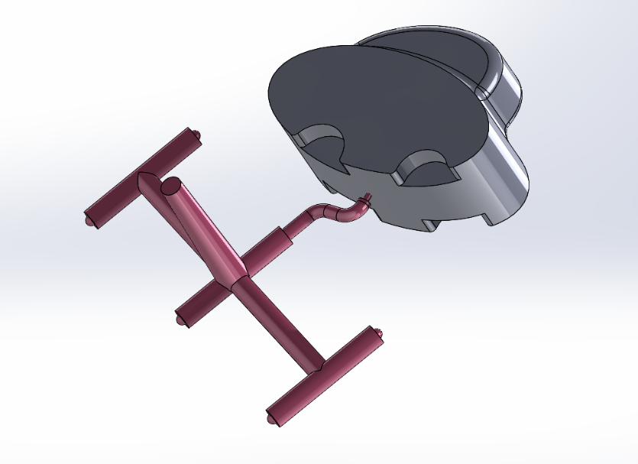

**Figure 9 –** SolidWorks image of “AS-MOLDED” part geometry including sprue & runner system

Save your “as-molded” part geometry as BOTH a SolidWorks part file AND as a 3D PDF file using the SAVE AS feature in SolidWorks.

**Use file names As-Molded_XX.sldprt and As-Molded_XX.pdf**, respectively. Recall, “XX” is your TWO digit team number. Make sure your PDF file is a 3D PDF!! Put copies of each file in your team folder on the \\mecad2\me240 drive space.

**STEP 6 – Save Mold Plate Layout as a Parasolid** file for use in NX. Open the LAYOUT Assembly & inspect it carefully to be sure it has all of the features that you will need machined into your mold. HIDE all parts except for the TWO mold insert plates that you are using.

SAVE TWO separate PARASOLID (*.x_t) files as follows:

1. EJ PLATE_TEAM_XX.x_t parasolid file containing ONLY the MOV Mold Plate (from Layout Assbly) CONTAINING the EJ PIN Holes. (Used to create Toolpath that drills/reams your EJ Pin holes)
2. CAVITY PLATES_TEAM_XX.x_t parasolid file containing BOTH the STAT and MOV mold plates (from Layout Assbly) modified to include your vehicle geometry, runners and gates. EJ HOLES must be suppressed. (Used to create Toolpaths that mill your cavities, runners & gates).

Save the Parasolid.x_t files in your own personal project directory for use during Project Week 3. The parasolid files are kept by you to use when you begin NC Toolpath generation in NX. Neither of the parasolid files need be submitted.

**Specific deliverables are:**

* As-Molded SolidWorks Part File. File Name 🡪 **As-Molded_XX.sldprt**
* As Molded 3D PDF File. File Name 🡪 **As-Molded_XX.PDF**
* Screen Shot of SolidWorks Mold Geometry. Approx 600 x 300 pixels. Good isometric view that shows only mold geometry for your mold inserts only (no pin plates) in a clear way (see sample image below). File Name🡪 **Mold Geom_XX.jpg**
* Both PIN Length & Pin MAP drawings. Hardcopy printed out signed & submitted to Instrictor/TA. Electronic Versions uploaded to Course Site.

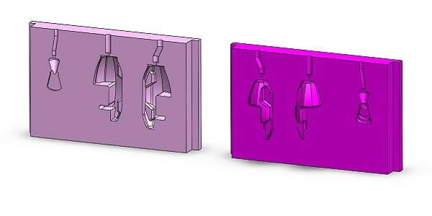

**Figure 10 –** Sample screen capture of mold plate geometry. Key size is 600 pixels WIDE

**All electronic files should be uploaded to** **\\mecad2\me240** **drive space unless otherwise noted.**

# TASK 5 – Generate Toolpaths Using NX CAM Package

Now that your mold geometry has been created in SolidWorks, your team will use the NX Manufacturing Module to generate the toolpath code to be used on the HAAS NC milling machine to produce your actual aluminum insert plates.

You will create TWO sepearte NX toolpath files using two separate NX Templates as follows:

**1) Drill & Ream Eject Pin Holes**

**NX Template Used:** NX CAM Template_EJECT HOLE DRILLING.prt

**Parasolid File Used:** EJ PLATE_TEAM_XX.x_t

**Machining Operations** Spot Drill, Peck Drill and Ream EJ Pin Holes only

**Output Toolpath File:** TEAM_XX_EJ_PINS.txt

**2) Mill Mold Cavities, Runners & Gates**

**NX Template Used:** NX CAM Template_CAVITY-RUNNER_MILLING.prt

**Parasolid File Used:** CAVITY PLATES_TEAM_XX.x_t

**Machining Operations** Cavity Mill, Profile, Contour Area, etc. All car cavity, runner and gate geometry.

**Output Toolpath File:** TEAM_XX_MOLD_PLATES.txt

Details on each of these two NX Toolptah [rpograms are provided below.

**TASK 5a: TOOLPATH for DRLLING & REAMING EJECT PIN HOLES**

**DOWNLOAD the NX CAM Template_EJECT HOLE DRILLING.prt** from Course Site under Project Week 3 Content Area. This template only has three tools defined—a spot drill, a #24 machine drill and a 5/32 reamer. It alos has three pre-defined opeations included—a spot drill, a peck drill and a reaming operation. This Template is to be used ONLY for drilling an reaming the EJ Pin holes in your mold plate blanks (PRIOR to actually machining your mold cavities on the HAAS NC Mill).

Import YOUR TEAMs EJ PLATE_TEAM_XX.x_t parasolid file. This file should ONLY contain your MOV mold plate WITH EJECTOR PIN HOLES included. Edit the workpiece to include the mold plate and define the stock to be “Part Outline”. If your EJ (MOV ) Plate is standard 0.75” thickness, DO NOT use any extra ZM+ stock thickness. If your MOV mold plate starting stock will be THICKER than 0.75” add a ZM+ extra thickness of 0.010” to your stock.

Define your drill/ream toolpaths by modifying the three predefined operations as follows:

Spot Drilling

Peck Drilling

Reaming

**THIS SECTION WILL BE UPDATED OVER SPRING BREAK**

**TASK 5b: TOOLPATH for MLLING Mold Cavities, Runners & Gates**

**DOWNLOAD the NX CAM Template_CAVITY-RUNNER_MILLING.prt** from Course Site under Project Week 3 Content Area. This template only has all of the end mills and ball mills that you will need to fully machine your mold plate geometry. It also contains a pre-defined Cavity Mill Operation and a pre-defined Contour Area operation.

Import YOUR TEAMs EJ PLATE_TEAM_XX.x_t parasolid file. This file should BOTH your STAT and MOV mold plates WITH NO EJECTOR PIN HOLES included.

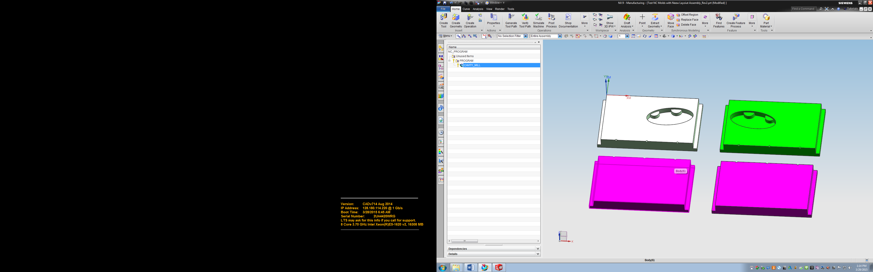

**Figure 11** – Layout Assembly imported into NX. All FOUR plates should be included

Your imported Parasolid geometery should look similar to that shown in . Your NC machining layout should include ALL FOUR mold insert plates and should show the coordinate system origin in the upper left corner of the UPPER STAT plate. **Make sure the MCS is located in the upper left corner** of the TOP stationary Plate. If it is not, contact the instructor.

You will create the cutting operations (e.g., Cavity Mills, Z-Level Profiles & Contour Areas) necessary using the tools provided in the NX Template to create finished machined geometry as close to your part geometry as possible. The number of operations, the types of operations and the tools used will be different for every team. Your job is to determine the best combination for your particular geometry.

Overall, your total cutting time should be somewhere in the 1.5 to 2 hour time frame. Toolpaths for simpler vehicle geometry may be shorter, more complex geometry may take longer. If you are over two hours, consult with the instructor or TA!!

**Define Your Workpiece(s) & Stock:** Once you have imported your Parasolid, go to Geometry View & Right Click on WORKPIECE to select EDIT to specify the part(s) that belong to that WORKPIECE as well as the Blank (use Part Outline with 0.000 offset). Specify a ZM+ limit value of 0.010” if you will be using thicker mold plate blanks (i.e., if you have male mold geometry). The ZM+ value you specify is the additional thickness (beyond 0.75”) that you need for your mold blank.

If you have two plates of differing starting thickness, make them TWO separate workpieces in NX (i.e., create a NEW workpiece for the other mold plate by right clicking on MCS🡪 Insert🡪 Geometry. Select “Mill Contour” and “Workpiece”. Give Your Workpieces identifying names such as “STAT Plate” & “MOV Plate” to readily identify them.

Machining Strategy

A good general strategy is to start with the largest tool that is reasonable and work your way down to the smaller tools. Initially, clear the bulk of material using Cavity Mill operations. Step down in tool size in subsequent copies of the Cav Mill Op using the previous tool size as a Reference Tool. For example:

CAV Mill ½ EM (No Ref Tool) 🡪 CAV Mill ¼ EM (1/2 EM Ref tool) 🡪 CAV Mill 1/8 EM (Use ¼ Ref Tool)

You can also choose to use your #D In-Process workpiece as Containment instead of a reference Tool. Most times either option works the same way, but sometimes the Reference Tool option can produce better results (fewer “straggler” cut paths).

Generally, it is a BAD idea to reduce the tool diameter by more than 50% in each step in the sample strategy listed above (e.g., don’t go directly from ½ EM to ¼ EM)

Typically, for the above Cavity Mill progression from large tool to smallest tool you will keep the same surface selection. You should simply be able to copy & paste the previous Cavity Mill operation, change the cutting tool, feeds & speeds and the reference tool as needed & regenerate.

Note that a “DUMMY” cavity mill operation (as well as a Dummy Contour Area Op) has been provided for you use in the NX Template. It has many of the important settings already specified for you. By basing your Cavity Mill Ops off of the “dummy” Cav Mill Op (using Copy & Paste) you can reduce some of the tedium & potential error associated with creating each new Op “from scratch” (see additional info on “Dummy” Op below).

After you have removed what you can with the above basic Cavity Milling strategy, finish up detailed areas with more refined/focused Cavity Mill, Profile or Contour Area operations. Here you may opt to use a combination of surface selection and trim boundaries and custom range depth definition to machine only where you need to.

Remember, CONTOUR AREA operations should be used ONLY to smooth out surfaces that are not vertical or horizontal (e.g., angled or contoured surfaces). Typically, Contour Area Ops are used to remove “stair-steps” remaining from prior Cavity Mill & profiling Ops. **Never CONTOUR area a surface without first removing the bulk of the material with a Cavity Mill or Profile.**

**Refer to the NC Machining Lab Tutorials as well as the “NX PROJECT HELP & HINTS” PPT available on Course Site under Project Week 3.**

Additional Notes on the “Dummy” Cavity Mill Op included in the NX Template

The Dummy CAV MILL Op included in the NX Project Template has had the toolpath specifications listed below explicitly defined. If you use the Dummy Ops, you should double check that these settings are correct for your particular tool and situation. If you create your OWN Ops from scratch, these are the settings you should be most concerned with.

**General Path Settings**

Cut Pattern: Follow Periphery

Stepover - % Tool Flat

Percent Flat Diameter (Stepover) - 10%

Common Depth per Cut – Constant at 10 %Tool

**Cutting Parameters**

Strategy – Climb Cut, Depths First

Pattern Direction – Outward

Containment Reference Tool – None specified for this sample operation

Stock – 0.000 allowance floor & walls

**Non-Cutting Moves**

Closed Engage – Plunge

Open Engage – Linear

Retract - Lift

**FEEDS & SPEEDS**

Spindle Speed – 12000 rpm (for ALL tools)

Feed per tooth (Chip Load) 0.003 in/tooth for ½ EM

SFM & CUT feed rate are calculated based on RPM & Chip Load

**MORE Feed Rates**

Approach & Departure – Rapid

Engage – 5 ipm (for all plunges)

First Cut & StepOver – 60%

The above Machining parameters in NX are the ones you should focus on selecting properly. Most other settings can be left as the default. Again, refer to the NC Machining Lab Tutorials as well as the “NX PROJECT HELP & HINTS” PPT available on Course Site under Project Week 3.

Of course, in certain cases, you may want or need to do something a bit “off the beaten path”. If so, ask the instructor or TA for assistance.

Tools Available

The table below shows the list of tools that will be made available to all teams. These tools have been predefined for you in the NX Project Template. The defined tools contain the correct length of cut, exposed tool length and tool holder geometry that will help NX to determine if you will have any difficulty in making the cuts that you specify. If NX tells you that you will experience a COLLISION during Toolpath Simulate OR if you are given warnings about length of cut, you need to correct these problems. Speak with the instructor as necessary.

BE SURE to specify the appropriate Spindle Speed (RPM) and CHIP LOAD (in/tooth) listed in the table below for the tool being used in EACH Operation within the Feeds & Speeds Option in NX.



**OTHER TOOLS may be able to be used in certain cases (e.g., to engrave very small letters or other features into your mold). If you think you might need additional tools not on the above list, contact the instructor.**

Verifying Your Toolpaths

As you create your operations, use “Toolpath Simulate” to view an animation of the actual material removal for a particular option (Right Click on Operation) OR for the entire set of Ops (Right Click on Program Group folder).

Be sure to select “Show 3D Material Removed”. It is suggested that you DO NOT select “Show Tool Path” (merely to avoid visual “clutter” while viewing the cutting simulation).

You can analyze your cut part after you have simulated the cutting operation in NX by either of two means—“Analyze” or “Show Thickness by Color”. Both of these options are available in the Toolpath Simulation Control Panel menu (will show at left of screen when you run Toolpath Simulate).

“Analyze” allows you to select a surface on your cut part to see the thickness of remaining material (in the direction perpendicular to the surface. Ideally the remaining thickness would be ZERO everywhere if your cut part exactly matches your CAD geometry.

“Show Thickness by Color” is a more general visual means of identifying regions with remaining uncut material (see ). This option uses a color contour plot to show the remaining thickness based a scale shown at the right of the screen. Note that you can adjust the thickness/color scale in the “Thickness by Color” menu (at left of screen). You can also see the actual remaining material thickness value by using the “Specify Point” option.



**Figure 12** – NX screen shot showing results of “Analyze By Color” after Toolpath Simulation

**Your Goal is to have ZERO material remaining everywhere although this is usually an unrealistic goal when you have contoured surfaces or sharp interior corners (i.e., poor DFM design). Asl questions as needed to accomplish this goal but realize that you are primarily responsible for determining the best strategy to do so.**

Getting Your Toolpaths Approved

When you think your toolpaths are complete & accurate, contact the Instructor or Graduate TA to have one of them view your operations for formal approval. Once you commit to having your operations officially approved, it will be a graded process that will be a part of yoru overall project grade. As such, it behooves your team to have a complete set of toolpath operations correctly specified. Errors in specification (e.g., feeds, speeds, depth steps, etc.) as well as glaring inadequacies or poor strategy will result in deductions in your toolpath assessment grade.

As such, we will NOT answer questions such as “can you take a look at our toolpaths & see if they look OK?” prior to the formal toolpath review process. We will answer SPECIFIC questions and or make suggestions on things such as using custom depths, trim boundaries or alternative approaches to machining.

Notify the instructor or Graduate TA when you are ready for formal toolpath review.

Post-Processing Your Toolpaths

Once formal toolpath approval has been granted, your team is ready to post-process the toolpath and prepare it for execution by the HAAS NC milling machine during your scheduled NC Machining time. Follow the Step outlined in Appendix E and complete the Checklist included in Appendix F.

Once those two items ae completed & the Checklist is approved you will schedule an NC Machining time with an undergraduate TA as outlined in Appendix G.

# TASK 6 – Injection Mold Your Vehicle

**THIS SECTION WILL BE UPDATED OVER SPRING BREAK!!**

Sign up for Time slot to Mold (1.5 hrs)

Info on Moldflow

Shot Volume in cc

Show up with Mold plates & EJ Pins

Assemble Mold

Mold Cars (min. 6 primed for BMS) + however many you want. Ideally run in Full Auto.

Prime 6 for BMS. Put in Ziploc Bag for Delivery Include any pertinent instructions for Broughal students

This Page Intentionally Blank

**APPENDICES**

**Appendix A** **– Display Base Tutorial**

**Appendix B** **– Details on Creating Electronic Deliverables**

**Appendix C** **– Mold Creation Tutorial**

**Appendix D** **– Mold Geometry Approval Form**

**Appendix E** **– Preparing Your Toolpaths for NC Machining**

**Appendix F** **- Mold Machining Preparation Checklist**

**Appendix G** **- Signing Up for NC Machining of your Mold**

**Appendix H** **– Injection Molding Process**

# APPENDIX A – Display Base Modeling and 3D Printing Instructions

1: Open the following drawing files

text_base_back.pdf

text_base_bottom.pdf

text_base_assy.pdf

2: Download the following part files

text_base_strip.sldprt

text_base_geom.sldprt

3: Using the supplied PDF Part Drawings, create the text_base_back and text_base_bottom parts in SolidWorks.

**Important Must do’s when making the text_base_back:**

When making text_base_back, make your sketch on the **Front plane** and make a rectangle **centered at the origin**.

Example of what the start of the text_base_back should look like. 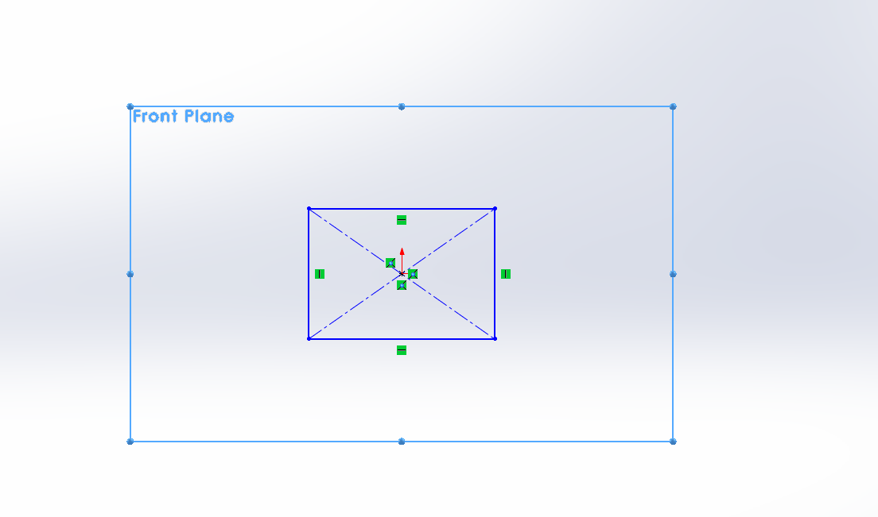

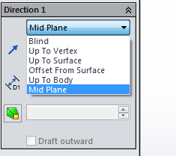When extruding the part, be sure to select **mid-plane.**

4: Once Both Parts are made, create an assembly file and insert the two parts you made plus the two parts you downloaded.

5: Mate all four parts together so it matches the provided Assembly drawing. Note that the Text Base Geom part (item 4 in assembly dwg) will be used only to create key holes in the back of the Text Base Back part. It WILL NOT be part of your 3D printed display part.

Be sure all of the parts are oriented correctly per the assembly drawing.

**IMPORTANT: To mate the Text Base Strip Part, mate its ORIGIN to the ORIGIN of the Text Base Back Part.** Be sure that the “align axes” radio button is checked in the Coincident mate options. Select the origins using the Fly Out Part Tree located in the part display window during the mate operation. This mate will only work properly if you constructed the text base back part correctly! That should be the ONLY mate you need for the Text Base Strip

To Mate the base back and the base bottom:

Select the edges of both the parts and mate the midpoint of both the edges. Add additional coincident pane mates to finish mating of the back and bottom.

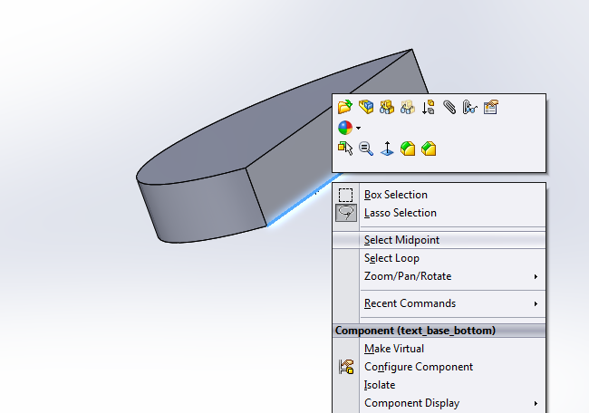

(Hint: Hold the ctrl key and select the back edge of the base back and bottom edge of the bottom base.)

6: Creating the Cavity

In the Feature tree, select the back part and edit part.

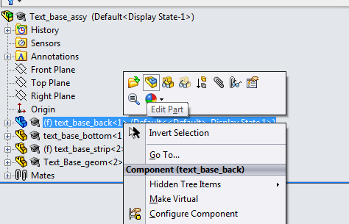

Then click on Insert > features > cavity

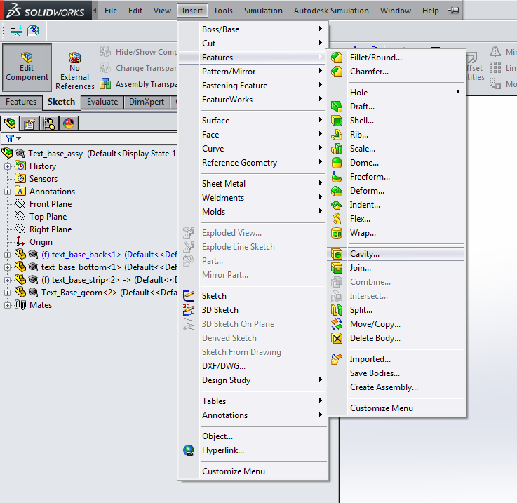

Next, in design components, click the text_base_geom part. (It should turn blue) Then hit the green Check mark.

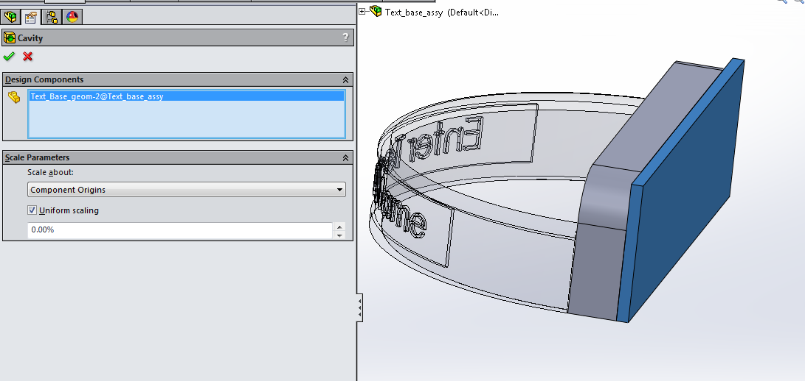

If you get out of editing the part and hide text_base_geom you should see key holes in the back of the back part.

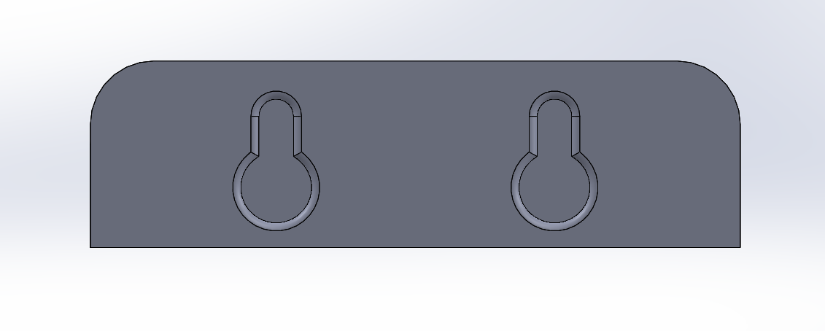

HIDE the Text Base Geom part once your key holes are created!

7: Updating your team name

In the feature tree, open the text_base_strip and open the “Open to Update Team name” extrude. Click edit sketch on the “Change this sketch to your team name” sketch.

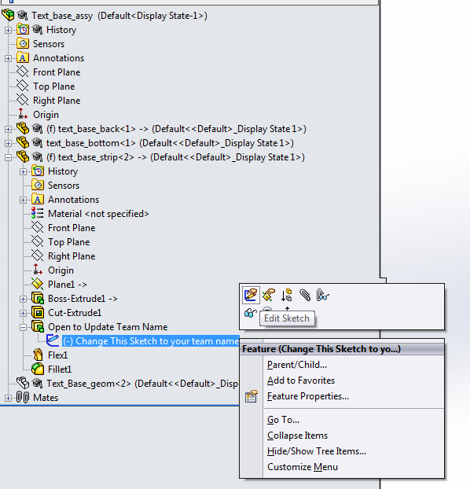

Double click the “Enter team name” on the Text Base Strip part and a box should pop up on the left where you can edit your text (You may have to double click the text on the part).

Click the checkmark when you are done and stop editing the part. Your team name should be wrapped around the part now. Be sure to center your name on the face.

**See Next Page for 3D Print instructions….**

**Printing Your Part using the MakerBot Ultimaker:**

**\*\*Do not use the Replicator2x\*\***

When you have finished modeling the part have the instructor check your part & approve it.

Save the part in SolidWorks directly as an STL File. See Project Manual 3D Prototype section for details on how to do this). Use Filename **“TEAM_XX_Display.STL”**

**Make sure you save the assembly file as a single .STL file**

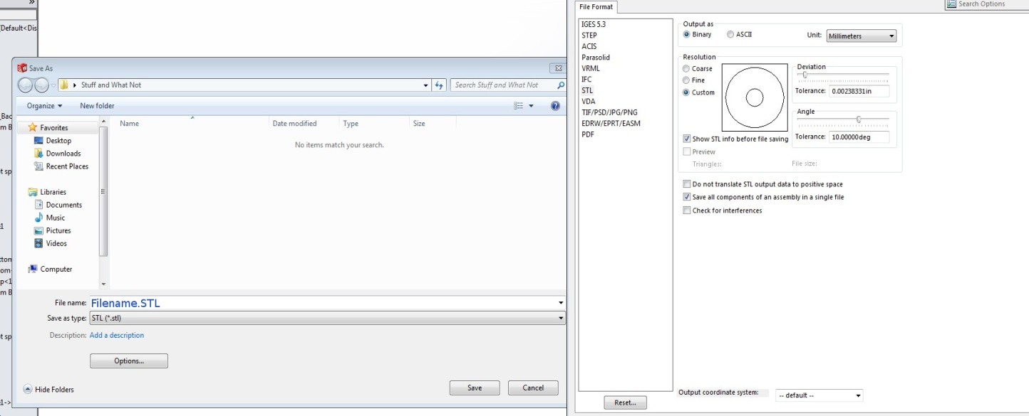

YOUR TEAM (Lehigh Students) is responsible for 3D printing the display base. The Broughal students will be responsible for printing the actual race vehicle prototypes later in the project.

Follow the Instruction & Info links provided below to learn how to prepare your part AND to actually print your part using the Makerbot “**ULTIMAKER**” 3D Printers located in Wilbur Powerhouse. Submit your actual 3D printed part to Professor Angstadt no later than 4:00 PM on the last class day prior to spring break. Your part should be cleaned up & ready for use.

Lehigh Additive Mfg Lab: <https://sites.google.com/site/lehighaml/home>

Ultimaker TUTORIALS: https://sites.google.com/site/lehighaml/home/ultimaker-kiosk

You will be assigned 2 or 3 other project teams with which you will need to coordinate your display base printing. We do NOT want to print jobs of individual bases. Instead we would like to print 3 or 4 teams at a time. Coordinate printing with your assigned partner groups to maximize machine utilization. Coordinate a time with representatives from the other teams to go to Wilbur, process your STL files into a single build file from the printer. Note that the three to four *.STL files will be combined into ONE *.x3g build file to be loaded on the Makerbot.

There will be DESIGNATED ULTIMAKER 3DP MACHINES to be used for ME 240 Displays. Make sure you use only those machines as **we need your part to be printed in the light gray or silver PLA material!!**

**ORIENT YOR PART** so that it rests on the flat bottom surface of the semi-circular display platform. This is the same orientation the display bracket will have when the actual vehicle is displayed on it.

**DO NOT use a RAFT** when 3D printing your Display Base!!!

# APPENDIX B – Details for Creating & Submitting Electronic Deliverables

**IF YOU DO NOT FOLLOW THESE INSTRUCTIONS PRECISELY YOU WILL BE PENALIZED POINTS ON YOUR PROJECT GRADE.**

**Every error will cost you one point (out of 100)**

* **ALL Files should be placed in your Team’s folder on the Fileshare location for ME 240. This file share space can be accessed as follows:**
  + In the CAD lab or any LU networked computer Active Directory, from Start Menu , choose Run and type in “\\mecad2\me240” and hit Return. After a moment a folder called “me240 on mecad2” should appear.
  + In the “me240 on mecad2” Create a sub-folder named TeamXX where “XX” is your team number. Place the electronic files (STL, PDF & jpg) in your sub-folder.
* **Use the prescribed filenames precisely as specified.**

**DUE prior to Spring Break**

Three items are due by 5:00 PM on the last class day before Spring Break as follows:

1. 3D PDF File of Vehicle Geometry (with color scheme & wheels)

2. Screen Capture Image of Solidworks Vehicle Geometry

3. STL File(s) of SolidWorks Vehicle Geometry.

**Details on creating each of these deliverables can be found below. You MUST follow these instructions to the letter!!!**

**Item 1: SolidWorks 3D PDF File**

From SolidWorks vehicle Part File or Assembly , Choose File🡪Save As.

Select “Adobe Portable Document Format (*.pdf)” as File ”Save as Type”.

Be sure to select the “Save As 3D PDF” check box in the lower left corner of SAVE AS dialogue window (see figure below). Open the PDF file & make sure that you can zoom, pan & rotate the vehicle model in Adobe as if your were viewing it in SolidWorks.



**USE FILENAME: “3D-PDF_Vehicle_XX.pdf”**

**Item 2: STL File**

This file will be used to produce a physical “Rapid Prototype” of your model at Broughal using the MakerBot Fused Deposition Modeling machine (FDM).

From SolidWorks Part File, Choose File🡪Save As.

Select “STL (*.stl)” as File ”Save as Type”.

You DO NOT need to specify any additional options. Click OK.

**USE FILENAME: “TEAM_XX.stl” (where “XX” is YOUR TEAM NUMBER)**

**Save multiple files (if needed) as TEAM_XX_01. STL, TEAM_XX_02.STL, etc.**

**Item 3: Screen Capture of Vehicle Solid Model**

Capture a Solidworks screen image of your vehicle solid model and save it as a jpeg image file.

Orient your vehicle in a view angle that shows as much detail as possible—an isometric view is recommended. Fill the screen with your image and capture the entire graphics window following the example image shown below.

BEFORE capturing your image, minimize the Solidworks “PART TREE” at left side of graphics window & re-shape window to get approximately 3:2 aspect ratio as shown below.

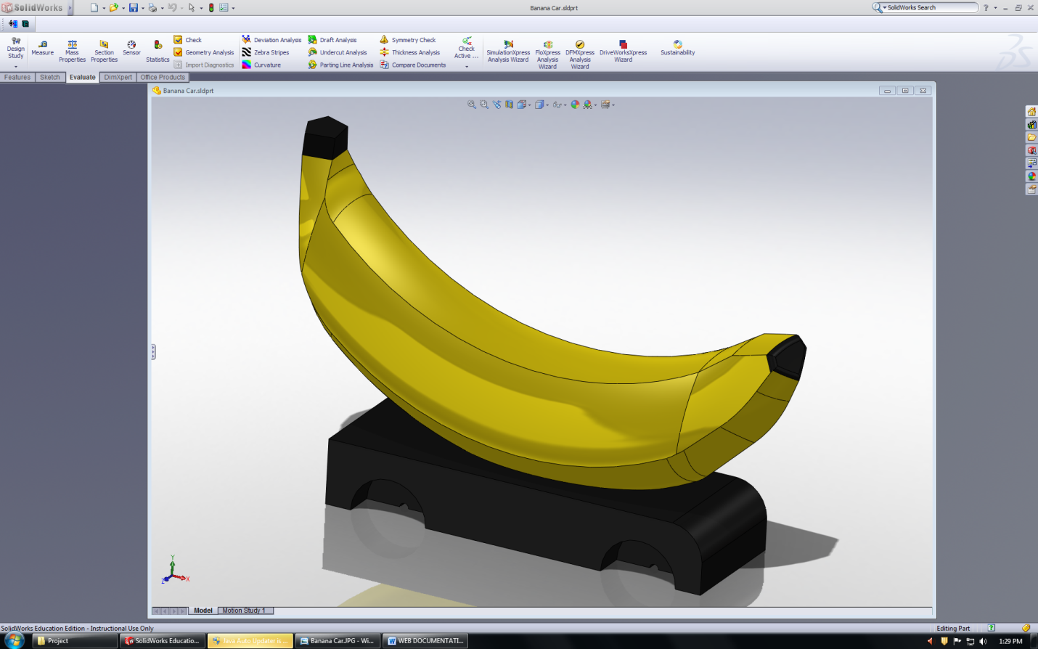

Once your window is sized, select FILE🡪 SAVE AS

Select SAVE AS TYPE as JPEG and specify the filename in SAVE AS WINDOW (shown below). Remember to use the Correct filename (Hint: it is NOT “BananaCar”)



Click on “OPTIONS” in SAVE AS Window to bring up “Export Options” Dialogue Box shown below.



Make sure you specify the EXPORT options as shown in the image above. Click OK.

**FILENAME: “CAD_Vehicle_XX.jpg”**

**ABOVE FILE NAME IS CASE SENSITIVE!!!**

Once you have saved the “CAD_Model.jpg” file, right click on the file in your file directory and select OPEN WITH🡪 PAINT (see image below).

Once the image opens in MS Paint, choose RESIZE, select the PIXELS option and type in a HORIZONTAL width of 600 pixels. Your height should automatically resize to something close to 400 pixels (between 350 & 450 is acceptable). If not, go back to SolidWorks, re-size the graphics window & re-capture the image file with a better aspect ratio.



Once you have re-sized the image, SAVE it (as the same filename) and then you may close MS PAINT. Your file size should be somewhere on the order of 40 to 50 KB & look something like the image below (except it should have WHEELS!!).

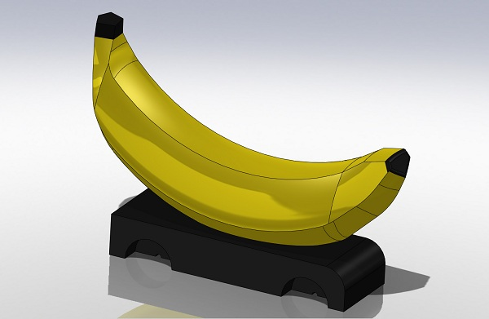

# APPENDIX C – MOLD CREATION TUTORIAL

* Make sure all necessary files have been downloaded from Course Site and saved to your H: Drive in one folder location. **DO NOT CHANGE THE NAMES OF ANY OF THE PARTS OR ASSEMBLIES DOWNLOADED FROM COURSESITE!!**
* **To Create Mold Geometry you will work out of the “CUT ASSEMBLY”!!**
* Under the assembly tab, choose “Insert Component”. The component you are inserting is the solid model(s) of your car geometry that you will use to create you mold cavities. This could be one or more individual parts. If you have multiple parts (e.g., two separate halves, you will repeat the procedure described below for each part. It is recommended that you bring ALL of the parts into the Cut Assembly and lay them ALL out before you cut any cavities.
* Once you insert the solid model of your car, you will need to use the “Mate” button under the assembly tab in order to orient the car in the manner you desire with respect to the mold plates. Notice that the ejector plate in the “Cut Assembly” has two different ejector pin arrays. Choose the top or bottom set of mold plates based on the ejector plate array that best matches up with your vehicle geometry when you are attempting to determine ejector pin locations. In this tutorial, the cavity and melt delivery creation is conducted on the top set of mold plates. The procedure is identical if you happen to choose the bottom set of mold plates

Part used for cavity creation

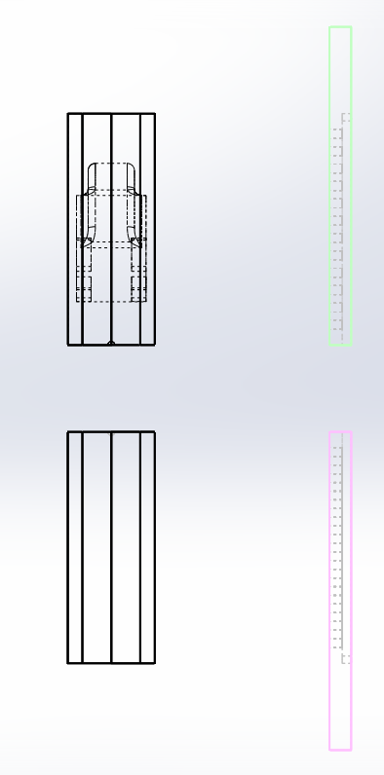 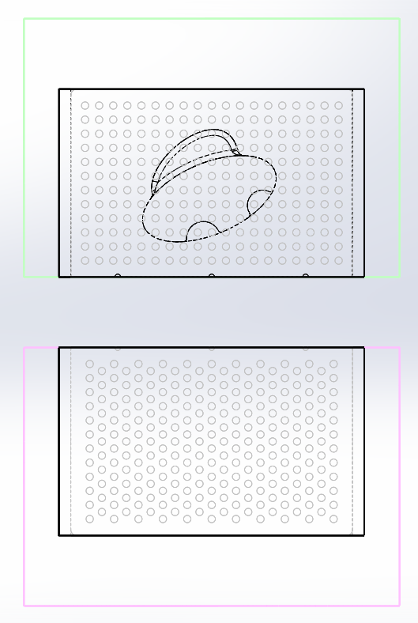

* It is recommended that you MATE your vehicle using the PARTING PLANE reference plane (provided in CUT Assembly) and DIMENSIONAL MATES to precisely locate the position and angular orientation (if needed) of your vehicle part models. This will prevent accidental shifting of your vehicle in the cut assembly and allow you precise control in positioning by adjusting the dimensional mates as needed.
* When locating your vehicle/cavities, consider not only the desired ejector pin locations, BUT ALSO the gate locations and resulting runner geometry.
* Once you have satisfactorily positioned your vehicle, you will EDIT the mold insert plate and use the CAVITY feature in SolidWorks to create the mold cavity using the vehicle geometry.
* In the assembly tree located along the left hand side of the screen, click on the desired mold insert plate in which you would like to create the cavity in and select “Edit Component”.
* Next click Insert🡪Features🡪Cavity

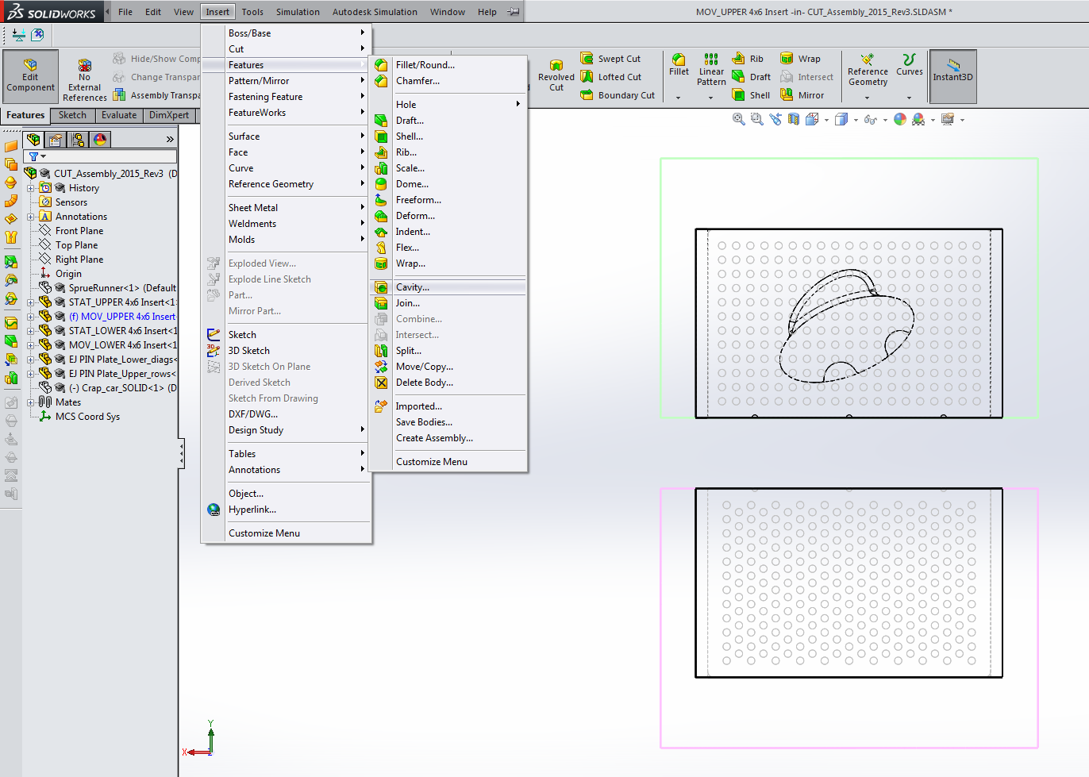

* You will then specify the part that you would like to use to create the cavity—this will be your vehicle geometry. (Refer to the video provided on Course Site for more detail).
* If your mold cavity is to be placed in both mold plates, you will have to repeat these steps for the other mold plate.

Repeat the above procedure for each component and each mold plate as required to create all cavities needed for your vehicle. If you need to create male protrusions in your mold, see below.

**Creating CAVITY & CORE Geometry for “Hollow” Vehicles**

This section will be about creating cavity & core geometry if your car requires it. The example shown is the car from the previous example, split into two pieces and hollowed out, one half is shown below.

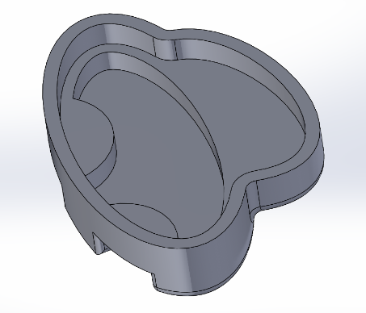

* Mate the part where you wish to have the parting line and create the female cavity in the respective mold plate using the same process explained above.

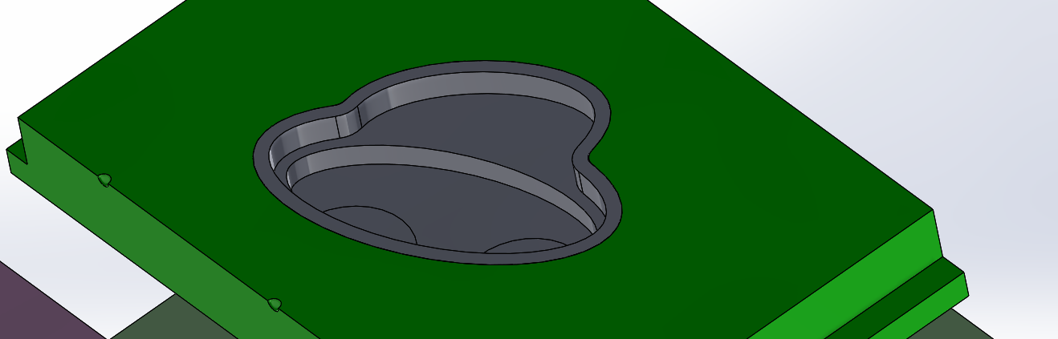

* You may be prompted, upon making the female cavity, to select the bodies you wish to keep as what will make up the male portion of the mold will not be removed by the cavity operation. Check the “Select Bodies” box and pick only the mold plate (DO NOT select the body that is the “floating islland” of material that is insid eteh hollow section of the car).

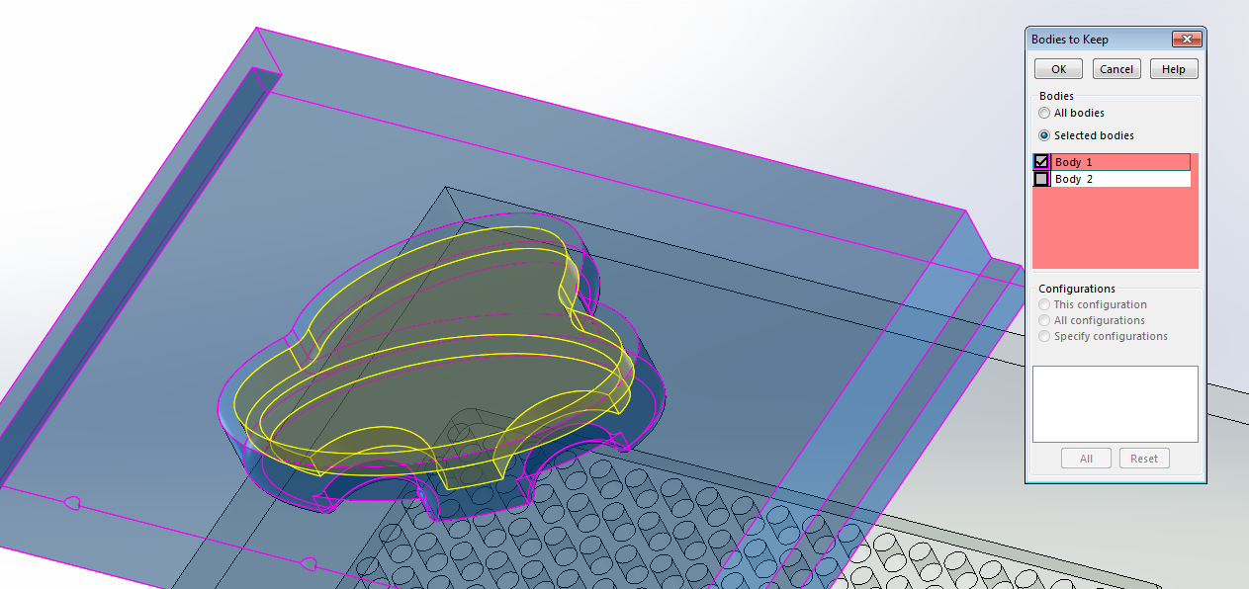

* Go to the opposite mold plate and edit the part. Create a sketch on the face of the mold plate and use the “Convert entities” tool to transfer the outline of your car the mold base. Hold shift to select the lines of the car geometry to be transferred.

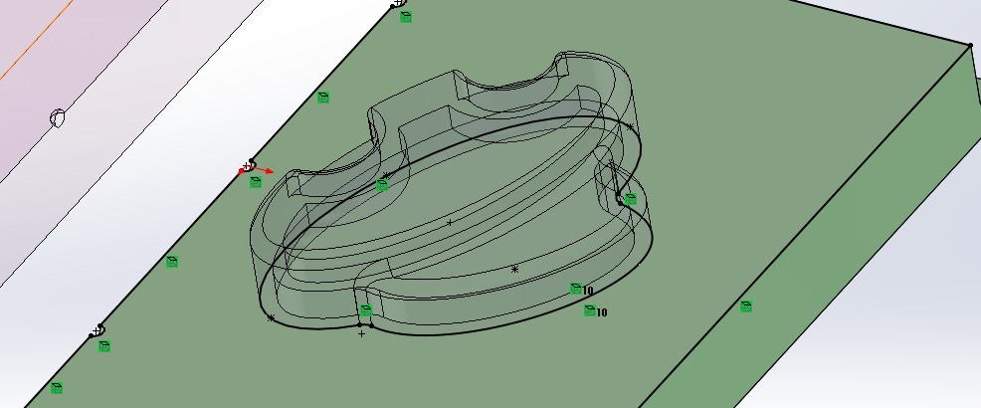

* 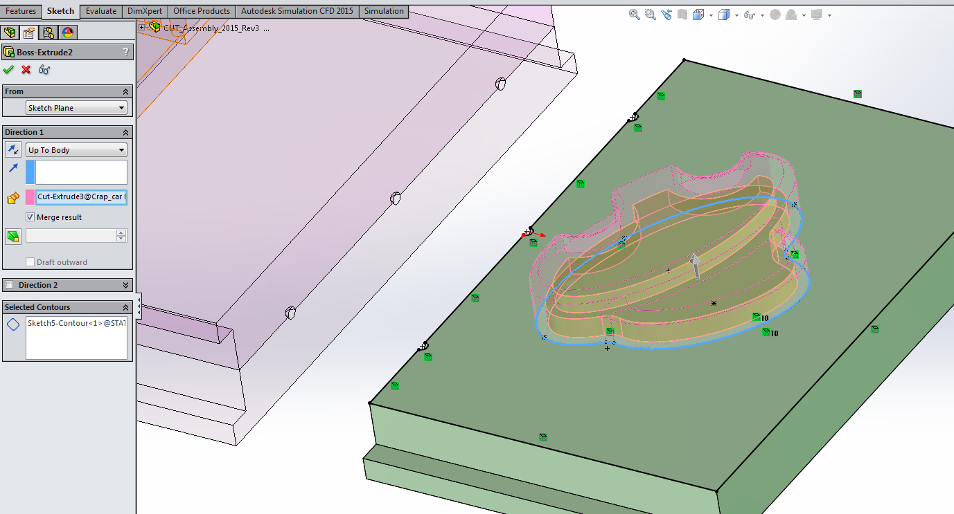Extrude that sketch using the “Up To Body” option in the extrude menu, and select the geometry of the car as the body:
* Double check that the extrusion fills the desired area and hit enter. Exit the Edit Part menu and hide the car geometry to see the completed male mold geometry.

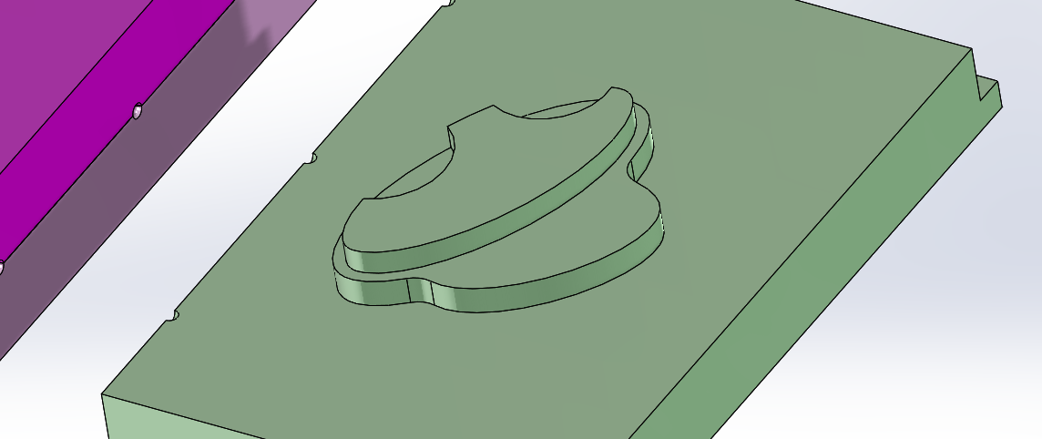

**Creating Runners & Gates**

Next you will have to create your melt delivery system (i.e. runner and gate). Typically the runner will be fully circular with about ¼” diameter (make it 0.26” diameter to avoid issues with 1/4” ball mill tool not being able to machine a channel that is exactly 0250. Smaller diameter runners (e.g., 0.13”) can be used in certain locations, but only with permission from Professor Angstadt.

* The most common technique for creating the runner is to extend the SPRUE-RUNNER part geometry by using an extrude or sweep to create the runner geometry and then use the cavity tool to cut them into the mold plates. Typically, you will use an extrude feature to bring the runner straight into the cavity from one of the three locations which are available to you. If you would like to create a more complicated runner design, perhaps to gate into the side of the part, a swept profile is recommended.
* **DO NOT directly cut your runners into the mold geometry. Create the runners by modifying the Sprue-Runner and then, using that geometry and the cavity tool, cut the runners into the mold plates in the same fashion as the cavity for the vehicle geometry.**
* For a simple extruded runner simply EDIT the Sprue-Runner Part, sketch the runner cross section on the Sprue-Runner end face (one of three ¼” diameter “drops”). Extrude/sweep from the drop location to a point approximately 0.1” away from the cavity. The 0.1” is the length of the restrictive gate which should be modeled to be .080” in diameter (It will be machined with a 1/16” ball mill.

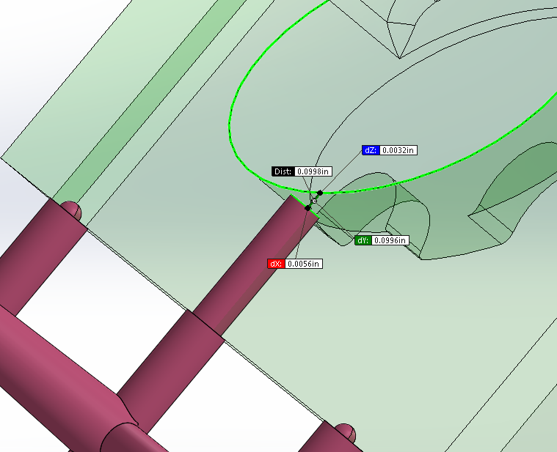

* Next simply sketch the cross section of the gate on the face of the end of extruded runner and extrude the sketched cross section past the edge of the cavity (or Up to Body or Surface of your vehicle geometry if still visible in CUT Assembly). Once all runners and gates are completed, end the editing of the SPRUE-RUNNER part. Now, Edit the STAT or MOV plates to CAVITY the runners into the mold plates in the same fashion that you used to create your vehicle cavities. You will need to do this once for STAT Plate & once for MOV plate so you have runner/gate geometry in each plate.

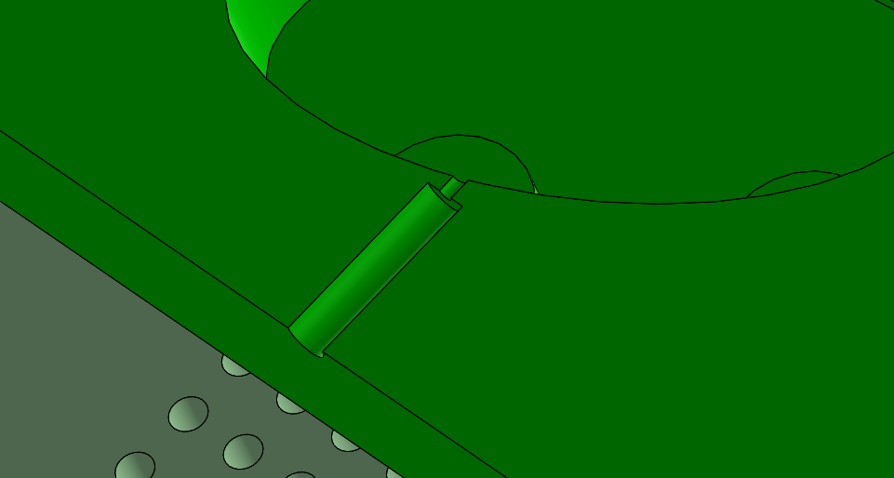

**SWEEPING a Runner**

Swept runners are more complicated to create than simple extrudes, but are often advantageous for allowing more flexibility in gating locations.

To create a swept runner it is necessary to sketch a trajectory and a cross section that will be swept along the trajectory.

* It is first necessary to click on the Sprue-Runner part and then click “Edit Component”. Then insert a sketch on the Parting Plane reference plane. This sketch will be the trajectory of the swept. Make sure the sweep path is PERPENDICULAR to the end face of the Sprue-Runner drop at the start of the sweep path. Be sure to leave a gap of 0.1” between the end of the sweep path trajectory and the cavity. This can be accomplished through the use of a construction line (as shown below) or simply ending the trajectory.

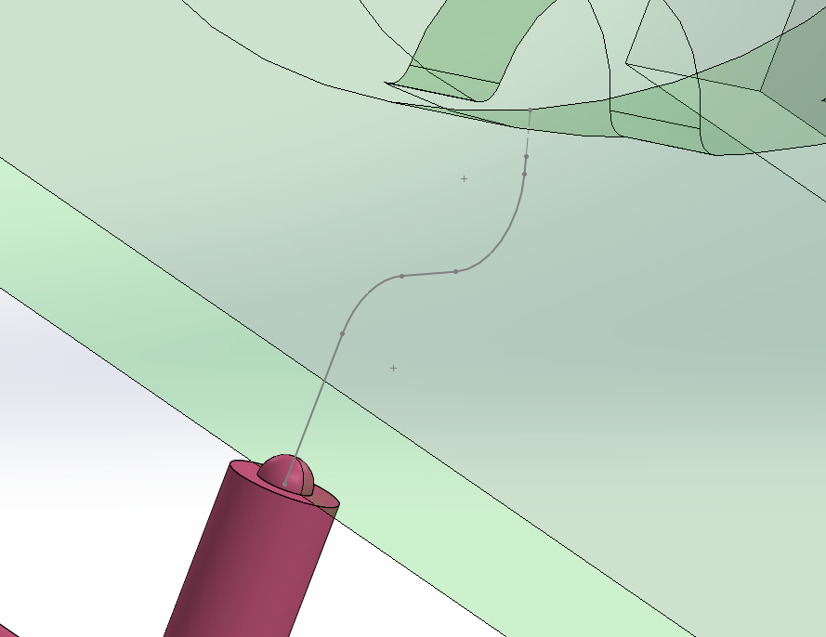

0.1” Construction line

* Next, create the sketch of the cross section (0.26” diameter circle!!) that you would like to sweep along the trajectory. This sketch is created right on the end face of the desired drop on the Sprue-Runner.

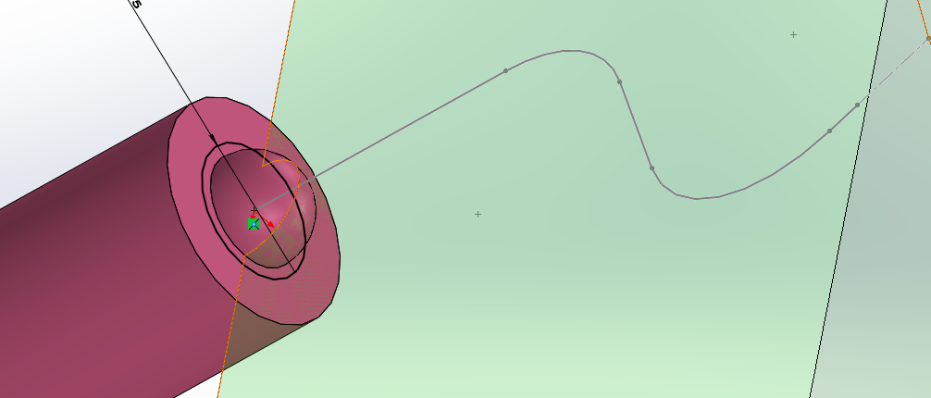

* Now use the SWEEP feature and pick the appropriate trajectory and cross-section to create the feature. Create the appropriate gate geometry (0.080”) to connect the swept runner to the car geometry. End editing of the SPRUE-RUNNER, Eidt the STAT or MOV mold plates and use the CAVITY feature to transfer the runner geometry into the mold plates.

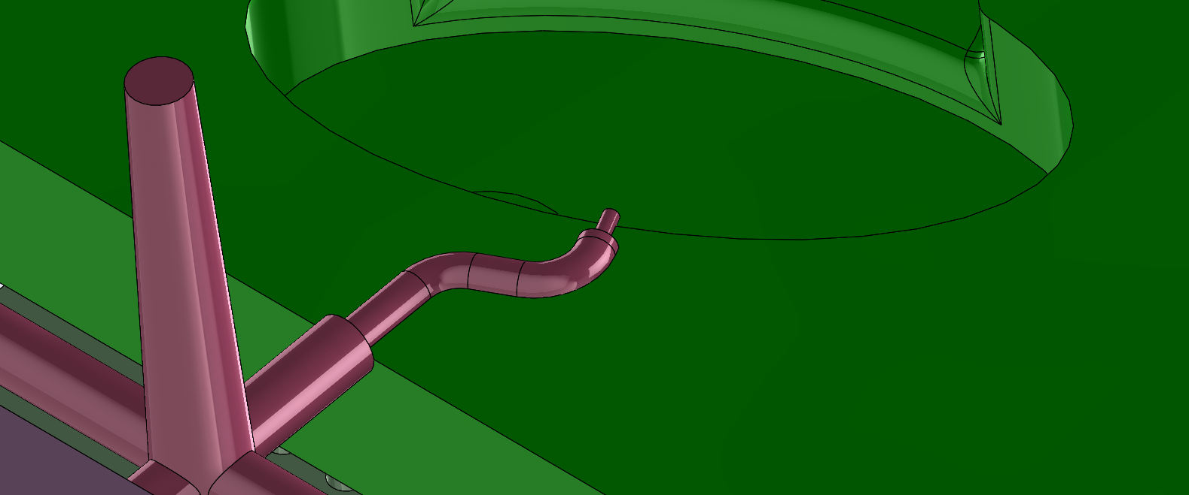

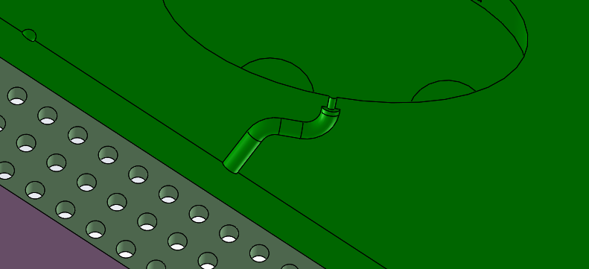

* Please note that the sweep trajectory should not be sketched with sharp corners. All turns in the runner should have a (sketch fillet) radius greater than the actual radius of the runner when sketching the trajectory. This prevents CAM (machining) issues and also is desirable for de-molding of the part on the injection molding machine.
* All sketches and reference geometry should be placed in part model tree of the SPRUE-RUNNER part being modified. That is you should be in “Edit Component” mode and then insert the sketches and reference geometry into the Sprue-Runner model tree rather than the assembly model tree. This may be slightly confusing so please ask if you are unclear.
* Unless specifically advised by the instructor or TA, runners and gates should be cut into BOTH molds plates.

ADDING EJECTOR PINS to your CUT Assembly

**Step 1 – Create Holes for your Ejector Pins in your MOV Mold Plate**

Once you have successfully created all of your cavity, runner and gate geometry in yoru CUT Assembly, HIDE all components EXCEPT for the MOV Mold plate (with yoru cavities) and the corresponding EJECT PIN Plate (upper or lower). EDIT your MOV mold plate and create a new sketch on the EJ HOLE SKETCH PLANE reference plane provided in the CUT Assembly. Once you are in sketch mode, go to the FRONT (XY) view and switch the display to Wireframe. So that it appears as shown below (sans blue highlighted circles). This allows you to see directly through your MOV plate to the ejector pin plate located behind it.



From the sketch menu, select CONVERT ENTITIES and select all of the holes in the Eject Pin plate that correspond to desired ejector pin locations in your cavities (you should have identified these locations when placing your cavity geometry. As you select each hole location it should highlight blue and appear in the Entities to convert selection box (see figure above).

Once all desired hole locations are selected, click the green check box to convert the circles into sketch entities in the sketch plane (should show up as black circles in EJ HOLE SKETCH PLANE.



While still in sketch mode, select the EXTRUDE CUT feature and specify THROUGH ALL. Click the green check to complete the CUT EXTRUDE operation. Your MOV Mold plate should now look similar to the one below (with all desired eject pin holes going through entire thickness of your MOV mold geometry.



Once all ejector pin holes have been created, you can exit editing of the MOV Mold Plate.

**Step 2 – Insert Ejector Pins into CUT Assembly**

SAVE your CUT Assembly!!

You will now begin to bring ejector pin parts into your assembly as needed.

Start with “PIN A” only if you require ejector pins that end flush with the original mold parting plane. These pins are exactly 4.142” in length and Pin A has already been adjusted to this lengthas this is a common pin length, especially for hollow vehicle geometry. If you do not need any pins of this length, the fist pin you will bring into your assembly is “PIN B”.

Note that in addition to PIN A, you have been provided EIGHT other ejector pin parts (“PIN B” through “PIN I”). You will add each of these pins, as needed for each pin of differing (unique) length you need for your mold plate. If you need MORE THAN eight unique pin lengths (nine if you include PIN A), contact Professor Angstadt.

Adding “PIN A” (if needed)

Insert an instance of PIN A into yoru assembly. MATE PIN A with the appropriate ejector pin hole where it will be located. It is highly recommended that you mate AXES of the pin and the hole (make Temporary AXES visible). You should mate AXES to mate pin into the hole (see below).



THEN, mate the interior pin head surface with the recessed surface on the back side of the EJECT PIN PLATE as shown below. This should fully mate your pin expect for rotation of the pin within the hole (which we are not concerned with). Make sure the head of pin is as shown below and NOT sunken into the PIN PLATE.



Since you only use “PIN A” where you need pins to end flush with the parting plane of your mold, they will automatically be of the correct length (already defined to be 4.142” long). There is no need to adjust the length of PIN A. Add other instances of Pin A as needed and mate them as described above.



To insert more pins, move next to adding “PIN B” and mate into a selected ejector pin hole as described above for Pin A. If you did not need any PIN A, you will start inserting pins with Pin B.

Pin B (and all other Pins C through I) are 6 inches long by default. Once inserted, they will protrude approximately 2 inches from the parting plane of your MOV mold plate as shown below.



Note that TWO instances of PIN B have been inserted into the CUT assembly since we know that both pins in the rectangular cavity will need to be of the SAME LENGTH. If there are other pin locations that require the SAME LENGTH pins, we would also insert PIN B instances there as well.

**Step 3 – Adjust Length of Ejector Pins**

We will now EDIT PIN B to modify its length so that it is flush with the floor of the rectangular cavity. Generally speaking, we want ejector pins to end flush with the surface of the mold cavity.

To change the length of PIN B, expand the PART TREE of the PIN B instance that is being edited. Within the part tree, EDIT the PIN LENGTH EXTRUDE Feature.



Generally you will modify the EXTRUDE LENGTH to extrude UP TO SURFACE and then select the surface that defines the bottom of the cavity (i.e., where the eject pin comes through the mold surface). Optionally you could choose UP TO BODY or simply extrude blind and estimate a good length for the pin visually (use this estimation method ONLY when the cavity surface is angled or contoured (not flat).



If new PIN extrude length looks OK, exit Part EDIT mode. Your CUT Assembly should update with ALL instances of Pin B having the new length as shown below.



REPEAT THE PRECEEDING PROCESS using PIN C, then PIN D, then PIN E, etc., IN ALPHABETICAL ORDER until you have all the pins you need for your Mold. If you need more than the 8 unique pin lengths provided (plus PIN A), contact Professor Angstadt.

**Step 4 – Modify Pin Length and Pin Map Drawings**

You have been provided an Assembly called “PIN Dimensions Assembly.SLDASM” as well as TWO SolidWorks Drawing Files: “PIN Length DWG.SLDDRW” and “EJ Plate Pin Map and TABLE.SLDDRW.

The PIN Dimensions Assembly has been created for you and contains all of the provided PIN files (PIN A through I) arranged in a convenient fashion for inclusion in the PIN Length Drawing file. You DO NOT need to do anything to this Assembly.

As you modify the SolidWorks Pin Part files (i.e., change the Pin Length) these changes are updated in the PIN Dimensions Assembly and reflected in the PIN Length Drawing. When you have created your complete CUT Assembly including all pins, you can OPEN the PIN LENGTH DWG file. What you should see is a drawing containing all nine ejector pins. Any pins that had their length modified by you should show the dimension of that length in the drawing. Any pins which were not used by you should show up in the drawing with the original 6 inch length.

**Editing the “PIN Length DWG.SLDDRW” File:** OPEN and modify the drawing file by editing all of the appropriate text notes in the file to accurately reflect you team name, date, etc., and most importantly, the quantities of each pin required. MAKE SURE THIS INFOIRMATION IS ACCURATE!

**Editing the “ EJ Plate PIN Map and TABLE.SLDDRW” File:** Open this drawing file and ADD the BACK VIEW of your MOV side Plate SolidWorks Part File (NOT the CUT Assembly, but JUST the MOV Plate part file). Modify the scale of the view to be 1:1.

Annotate with “Balloons” containing text to label each EJ Pin hole shown in the plate as “A”, “B”, “C”, etc. corresponding to the EJ PIN that is located in each hole.

In addition, complete the data in the table at the bottom of the page, confirming the quantity and length of each designated pin. Note that the total at the bottom will automatically update.

This drawing will be your MAP for assembling your Movable mold half ejector assembly when it comes time to actually injection mold your vehicle.

SAVE a version of each of the TWO drawing Files as a PDF Document. Add your TEAM NUMBER in the file name. View the PDF Document to make sure it is complete and accurate. Print out a copy of each and contact Professor Angstadt for approval of your mold geometry BEFORE you proceed to creation of your machining toolpaths.

SAMPLE VERSIONS of each of these two drawings are shown in APPENDIX D for your reference.

# APPENDIX D1 – SAMPLE PIN LENGTH DRAWING



# APPENDIX D2 – SAMPLE PIN MAP & MOLD GEOMETRY APPROVAL SHEET



# APPENDIX E: Preparing Your Toolpaths for Mold Machining

Once you have Post-Processed your file from NX you still need to make a few modifications to the file to prepare it for use on the HAAS CNC. These changes are summarized below and then explained in greater detail in the supporting documentation that follows. Check off each of these tasks as you complete them on the Mold Machining Preparation Checklist (Appendix F).

**Post-Processing Summary**

1. Re-name your file to *.txt
2. Make sure you have the correct toolpath file from NX
3. Add “O-Code” and file identifier comment
4. Add G-code identifier for the HAAS machine coordinate system being used
5. Remove extraneous colons and extra “Tool references” from file
6. Save copies of toolpath *.txt and NX *.prt files to H:/public folder

**Step 1 – Re-Naming your file**

Find the file you saved when you post-processed your toolpath in NX. It may have a *.ptp or *.tp extension. It will be located in whatever folder you selected (or defaulted to) in the post-processing step in NX. RENAME the file “TEAM_XX.txt” where “XX” is your team number (e.g., “TEAM_07.txt”).

**Step 2 – Checking that you have the correct toolpath file**

Open your *.txt toolpath file. If it looks like that shown in Figure 1 below (has the header on it) you have mistakenly saved the LIST File that displayed on the screen after you post-processed and possibly also mistakenly over-written your actual toolpath file. This file will NOT run on the HAAS CNC.



Figure – Sample LIST OUTPUT file—this is NOT the correct toolpath File

You cannot simply delete this header, YOU MUST either find the original file (*.tp or *.ptp) that you posted from NX, OR simply go back and re-post your toolpath file from NX.

. 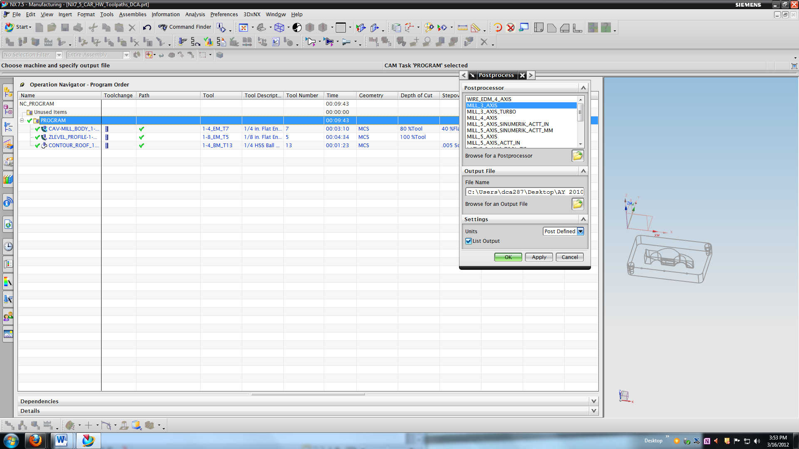

Figure – NX Post-Processor menu

If you do re-post from NX, UNCHECK the “List Output” check box (see above), then the List file will not appear & you will not be tempted to save it.

Your toolpath *.txt file from NX SHOULD look like this (although you will be modifying it below)…



Figure – Correct toolpath file posted from NX

**Step 3 – Adding O-Code and File Identifier**

Although your toolpath file has a filename “TEAM_XX.txt” the HAAS CNC will not use this filename as the unique file identifier. Instead, you will have to add the “O-code” which WILL BE the unique identifier used by the HAAS. The “O-code” is a code that you will manually type into your TEAM_XX.txt” file on the line immediately after the “%” sign that is the first line of your toolpath code.

On the second line of your code type in “O240XX(Team XX)” where again “XX” is your team number. The “O” is the LETTER O and NOT a ZERO. The text in parentheses that follows the O-Code is simply a comment that confirms to the machine operator that this is indeed your team’s toolpath file. The line you enter should look like that indicated by “A” in the figure below.



Figure – Example of partially modified toolpath file.

**Step 4 – Specifying the Machine Coordinate System**

The HAAS CNC can have multiple coordinate system origins defined by the operator that can be used for different machining jobs. Each different coordinate system origin is identified by a “G-code” number. The particular origin that will be used to machine your mold plates is identified by “G114”. Therefore, you will need to type “G114” into your *.txt toolpath program at the end of what should be the third line of code (See item “B” in Figure 4 above) . Note that the coordinate system specified corresponds to the coordinate system you specified as the WCS in NX.

**Step 5 – Removing Extraneous Colons “:” and Tool References**

The NX post-processor inadvertently inserts extra code related to tool changes that is not needed for our HAAS CNC—these must be removed to prevent execution errors while running your program.

In the toolpath file the code “M06” indicates a tool change operation. More specifically, the code “T07 M06” indicates a tool change to tool number 7. Every tool change should be of the latter form indicated above and shown as item “C” in Figure 4 above. Note that the line of code following the tool change has ONLY the code “T05” and is NOT followed by “M06”(indicated by item “D” in Figure 4). This tool (T05 in this case) is actually the tool that will be used next by the program—NX appears to insert this code to let the HAAS CNC know what tool it will need to load at the next tool change.

This command (without the requisite “M06”) causes an error ion the HAAS. As a result this command must be DELETED—that is, the entire line of code that contains the stand-alone code “T05” (item “D”) WITHOUT an ensuing “M06” should be deleted. Do NOT delete the “T07 M06” command on the previous line (item “C”).

**IN ADDITION, every tool change command has a line number that starts with a colon (“:”) instead of the letter “N” –e.g., “:0030” instead of “N0030” in line of code for item “C”. At each tool change command in your program, DELETE the “:” and replace it with an UPPERCASE “N” (not sure if the case matters, but better safe than sorry).**

You will encounter a similar situation at EVERY tool change in your toolpath code. You will want to delete the second line containing only “TXX” at every tool change. To do this, use the “EDIT/FIND” command in Notepad to search for and find every “M06” command in your toolpath file (see Figure 5 below). **Similarly, delete and replace every “:” with “N” as explained above.**



Figure – Using “FIND” command in Notepad to find “M06” tool changes in toolpath file

For every “M06” command you find, there should be an unwanted “TXX” only command on the following line of code that you will want to delete. The only exception to this will most likely be your final tool change (since there is no “next” tool to be loaded).

**Step 6 – Save copies of your Files to H:/Public folder and CourseSite (toolpath file only on CourseSIte)**

Both your toolpath *.txt file and your NX *.prt file must be saved in a location where it can be accessed by the ME 240 staff. The reasons for this are two-fold:

1. You must have access to your *.txt file from the PA 271 PC to load the file onto the HAAS CNC.
2. All team members and ME 240 staff must have access to your NX file should any problems arise during the machining of your mold (e.g., to correct any minor problems).

Be sure to update the NX file on the public folder if anyone on your team makes any changes after you sign up for a machining time.

Indicate the AFS username for the public folder where your files will be stored (e.g. “dca287”).

# APPENDIX F: Mold Machining Preparation Checklist

Team Number : _________ Contact Name: _______________________

Contact E-mail: _______________________

Need Thick Mold Platen Y N Contact Phone: _______________________

Required STAT Blank Thickness: __________ (will only be used in “emergency” or “no-show” situation)

Required MOV Blank Thickness: __________

**Toolpath Preparation Tasks**

___ Toolpaths approved ___ Process Plan attached

___ NX In-Process Screenshots attached ___

**Toolpath Post-Processing Tasks**

___ Toolpath File Name correct (“Team_XX.txt”)

___ Verified Toolpath file was correct file (Not LIST Output file)

___ O-Code inserted

___ “(Team XX)” Comment inserted immediately after O-Code

___ “G114” MCS code inserted

___ Extraneous “TXX” tool references and “:” colons deleted

___ Toolpath *.txt file saved to Public Folder AND uploaded to CourseSite

___ NX *.prt file saved to Public Folder (AFS username: _______________)

***All above tasks have been completed and checked by Team as indicated***

Team Member: _________________________________ Date: _________________

Approved by: ___________________________________ Date: _________________

**\*\*\*\*\* Attach all documentation (clip or staple together) and submit to Instructor or Grad T.A. \*\*\*\*\***

Undergraduate TA for NC Machining & Injection Molding: ______________________________

**YOU MUST SIGN UP for a Mold Machining Time Slot within 24 hours of Approval**

**(SEE APPENDIX G)**

# APPENDIX G: Signing Up for NC Machining of your Mold

Once you have completed the Mold Machining Preparation Checklist you need to schedule a day & time to machine your molds. You will machine your mold during a 4 hour time slot using either the HAAS DT-1 or the HAAS VF-2 milling machines (choose one based on availability). You will coordinate your machining day & time with one of the undergraduate teaching assistants. The same UGTA will supervise the machining of your molds as well as the injection molding of your vehicles.

Follow the procedure below to contact and schedule an NC machining time with your designated UGTA:

1. E-Mail your teams UGTA to notify them that you are ready to schedule a machining time.
2. Use the following Subject Header in your E-Mail: “**TEAM XX NC MOLD MACHINING**”

(Note “XX” is your team number)

1. Indicate in your e-mail that you are ready to machine your molds and PROPOSE AT LEAST THREE days & times that your team is available to machine.

* Refer to the NC Machining Schedule posted outside of the Dravo Student Shop for available times. **DO NOT sign up for a time until you have confirmed availability of your UGTA!!!**
* AT LEAST ONE team member must be available during the entire machining process

MORE ON NEXT PAGE….

1. Await a response from one of the UGTAs, and communicate via e-mail to coordinate a day & time.
2. Once you have CONFIRMED a date & time with a UGTA, sign your team up for that time slot ASAP!! If your time has been taken by another team, continue communication with your UGTA until you have successfully signed up for an available time.
3. SHOW UP ON TIME for your mold machining time slot.
4. Once your molds have been successfully machined, **BEFORE YOU LEAVE**, sign up for an injection molding day & time (coordinate with your UGTA). The molding sign-up sheet will be available on the hallway window outside of the Polymer Processing Lab (PA 274).

# APPENDIX H: Injection Molding Process Sheet

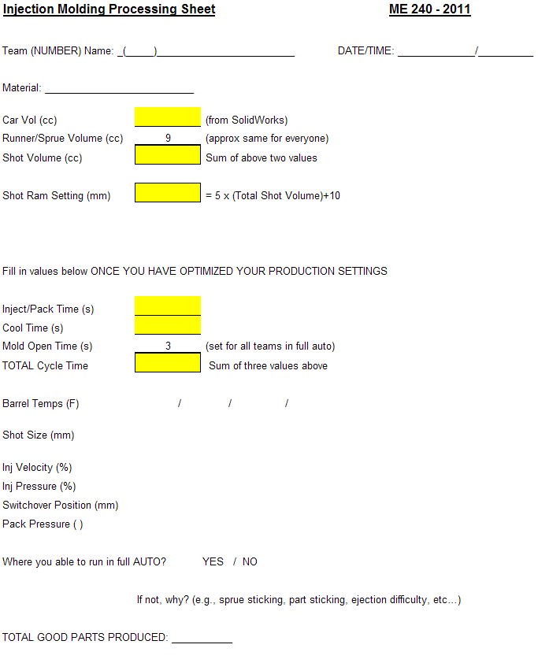

Checklist:

__ Primed 6 cars for Broughal ___Cars in Baggy in Poly Lab ___Team # on Baggy